
Cyberbullying Classification and Toxicity Prediction Using Supervised Learning Techniques

UNIVERSITY OF HERTFORDSHIRE
School of Physics, Engineering and Computer Science

Advanced Computer Science Master's Project(7COM1039)
Student Name: Jaswinder Singh Munjal
Student ID: 21060491
Supervisor’s Name: Huma Zia

MSc Final Project Declaration
This report is submitted as part of the requirements for the award of the Master of Science in Advanced Computer Science at the University of Hertfordshire (UH). The work presented in this report is entirely my own, except where due reference has been made to the work of others.
Ethical Considerations
This project did not involve any direct participation from human subjects.
Permissions
I grant permission for this report to be stored and made accessible by the University of Hertfordshire, with appropriate acknowledgement of its authorship.

Acknowledgement
This project was carried out as part of the Advanced Computer Science Master’s programme (7COM1039) and has been a valuable learning experience, offering an opportunity to apply theoretical knowledge to practical challenges in the areas of cyberbullying detection and textual toxicity analysis.
I would like to sincerely thank my supervisor, Huma Zia for his consistent guidance, constructive feedback, and support throughout the course of this project. His direction played a key role in improving the structure of the methodology, enhancing the quality of analysis, and ensuring academic discipline was maintained.
I am also thankful to the academic staff of the Department of Computer Science for delivering a strong theoretical foundation through their teaching. The programme structure, learning resources, and academic environment contributed significantly to the successful completion of this work.
In addition, I am grateful to my friends, peers, and family for their encouragement and moral support during demanding phases of the project, which helped me stay focused and motivated.
This project represents an important step in my academic and professional growth, and I am privileged to have worked on a subject that addresses meaningful societal challenges using modern computational techniques.

Abstract
- The widespread use of social media has led to an increase in cyberbullying and toxic online communication, making it difficult to monitor harmful content using manual methods. Due to the large volume of text generated every day, there is a need for automated systems that can identify abusive language and assess its severity in a reliable manner. This project focuses on analysing online textual data using machine learning techniques to detect cyberbullying and estimate toxicity levels.
- Text data is first pre-processed using Natural Language Processing methods to remove noise and convert raw text into a structured format suitable for machine learning models. Traditional classification algorithms are trained to identify cyberbullying-related content, and their performance is compared with a transformer-based model, DistilBERT, to evaluate differences in accuracy and behaviour. In addition to classification, regression-based models are used to predict multiple toxicity-related scores, allowing the system to measure the intensity of harmful language rather than providing only a categorical label.
- To improve the transparency of model predictions, explanation techniques such as SHAP and LIME are applied to highlight the words that influence classification decisions. The final system combines cyberbullying detection, toxicity prediction, and interpretability, and presents the results through a web-based interface for ease of use. The outcomes of this project demonstrate that machine learning can be effectively applied to support automated and interpretable cyberbullying analysis in online environments.

Contents
MSc Final Project Declaration 2
Acknowledgement 3
Abstract 4
Chapter Overview 9
CHAPTER 1 10
Introduction 10
Aim of the Project 11
Research Questions 11
Hypotheses 11
Objectives of the Project 12
Short Description of the Idea 12
Problem Statement 12
Proposed Solution 13
CHAPTER 2 14
Literature review 14
Enhancing Cyberbullying Detection: A Comprehensive Framework Using Machine Learning, Deep Learning, and NLP Techniques 15
Cyberbullying Detection using Deep Learning Algorithms 16
Background research 18
Advanced Cyberbullying Detection: A Hybrid Model Integrated with Naïve Bayes 18
Effective Automatic Cyberbullying Detection Using a Hybrid Approach SVM And NLP 18
A Study on Automatic Detection of Cyberbullying using Machine Learning 19
Cyberbullying Detection using Pre-Trained BERT Model 20
Cyberbullying Detection using Deep Learning 21
Comparative Summary of Cyberbullying Detection Studies 22
CHAPTER 3 26
Ethical, Legal, Professional, and Social Considerations 26
Ethical Considerations 26
Legal Considerations 26
Professional Considerations 26
Social Considerations 27
Laptop Hardware and Software Specifications 27
Software Requirements 28
Overview of the Methodological Framework 28
CHAPTER 4 44
Project Journey, Challenges faced and Learning Outcomes 44
Project Journey 44
Challenges Faced 44
Insights Gained 45
Learning Outcomes 45
Chapter Summary 45
CHAPTER 5 46
Introduction to Results 46
Cyberbullying Classification Results 46
Test Dataset Results for Best Classical Model 47
Discussion 49
Answers to Research Questions and Validation of Hypotheses 59
CHAPTER 6 62
Conclusion 62
Summary of Contributions 63
Future Work 63
Final Remarks 63
References 65

Table 1 Comparative Summary of Cyberbullying Detection Studies 20
Table 2 Laptop Hardware and Software Specifications 22
Table 3 Software Requirements 23
Table 4:Cross validation performance of classical classification models 40
Table 5 Overall Test Performance 41
Table 6 Class-wise classification results for the Random Forest model 41
Table 7 Macro and Weighted Average Analysis 42
Table 8 DistilBERT training and validation performance 44
Table 9 Overall test performance of DistilBERT 44
Table 10 Class-wise classification results for DistilBERT 45
Table 11 Comprehensive comparison between Classical model and DistilBERT 46
Table 12 Mean Squared Error (MSE) for toxicity attributes 50
Table 13 R² score for toxicity attributes 50

Figure 1 Results on test data for 305 labelled dataset. 13
Figure 2 Results on test data for 500 labelled dataset 13
Figure 3:Flowchart illustrating the methodology for cyberbullying detection 14
Figure 4:Performance of Different Classifiers 14
Figure 5:Proposed System Architecture 15
Figure 6 evaluation metrics 16
Figure 7Results Value of All Models 17
Figure 8 Diagram for general steps of cyberbullying detection. 17
Figure 9 Architecture Overview 18
Figure 10 Accuracy Comparison Chart 19
Figure 11 Laptop Hardware and Software Specifications snap 22
Figure 12 Data Preprocessing 24
Figure 13 TF-IDF representation 24
Figure 14 The class distribution 25
Figure 15 Analysis of raw tweet length 26
Figure 16 Analysis of clean tweet length 26
Figure 17 Cleaned token count distribution 27
Figure 18 Top 30 tokens {cleaned} 27
Figure 19 Exploratory Data Analysis for Toxicity Intensity Prediction 28
Figure 20 Toxicity vs Retweet Count 29
Figure 21 Classical Machine Learning Models 30
Figure 22 Transformer-Based Model (DistilBERT) 31
Figure 23 Multiple regression models are trained and evaluated 32
Figure 24 LIME (Local Interpretable Model-Agnostic Explanations) 33
Figure 25 SHAP (Shapley Additive explanations) 33
Figure 26Evaluation of Cyberbullying Classification Models 34
Figure 27 Evaluation of Toxicity Regression Models 35
Figure 28 Model Persistence and Reusability 36
Figure 29 Web Application Deployment 1 37
Figure 30 Web Application Deployment 2 37
Figure 31 Web Application Deployment 3 37
Figure 32 Graphical Interpretation 42
Figure 33 F1 score comparison 43
Figure 34 Confusion Matrix 44
Figure 35 Training Time and Computational Cost 45
Figure 36 model comparison 47
Figure 37 SHAP Analysis for the Classical Model 48
Figure 38 LIME Analysis for the DistilBERT Model 49
Figure 39 Mean Squared Error Analysis across toxicity targets 50
Figure 40 R² Score Analysis across toxicity targets 51

Chapter Overview
This project report is structured into six chapters, each addressing a specific phase of the research and system development process for cyberbullying detection and toxicity measurement using machine learning techniques.
Chapter 1: Introduction
This chapter introduces the problem of cyberbullying in online platforms, outlines the research motivation and problem statement, and presents the project aims, objectives, and an overview of the proposed solution.
Chapter 2: Literature Review
This chapter reviews existing studies on cyberbullying detection and toxicity analysis, covering traditional machine learning, deep learning, and transformer-based approaches, and identifies key research gaps.
Chapter 3: Research Methodology
This chapter describes the methodological framework of the project, including ethical considerations, dataset selection, preprocessing, feature extraction, model development, evaluation metrics, explainability methods, and deployment strategy.
Chapter 4: Project Journey, Challenges, and Learning Outcomes
This chapter discusses the project workflow from planning to deployment, highlights challenges encountered during development and summarises key learning outcomes.
Chapter 5: Results, Analysis, and Validation
This chapter presents and analyses the experimental results for cyberbullying classification and toxicity prediction and evaluates model performance and explainability outputs.
Chapter 6: Conclusion and Future Work
This chapter summarises the project contributions, discusses limitations, and outlines potential directions for future research and improvements.

CHAPTER 1

Introduction
The use of online platforms for communication has increased significantly in recent years. Social media, messaging applications, and online discussion forums allow people to share opinions and interact with others easily. Along with these benefits, online platforms have also become spaces where harmful behaviour such as cyberbullying and abusive language can occur.
Cyberbullying refers to the use of digital communication to insult, threaten, or harass individuals or groups. Unlike traditional bullying, online abuse can happen at any time and may spread quickly to a wide audience. This type of behaviour can cause emotional stress, reduced self-confidence, and psychological discomfort for those affected. Because of these consequences, identifying cyberbullying has become an important concern for online communities and service providers.
The large volume of text generated every day makes manual monitoring difficult. Human moderation requires significant effort and may lead to delayed or inconsistent decisions. Automated text analysis using Machine Learning and Natural Language Processing offers a practical approach for handling large amounts of online content. These techniques allow computers to learn patterns from data and identify harmful language more efficiently than manual methods.
Many existing approaches focus only on classifying content as harmful or non-harmful. While this helps in basic detection, it does not show how severe or intense the harmful language is. Two messages may be classified under the same category but differ greatly in their level of toxicity. Estimating the severity of abusive language can provide more useful information for moderation and analysis. (Sathya, 2024)
Another challenge is understanding how predictions are made. When decisions produced by machine learning models are not clear, users may find it difficult to trust the results. Explainable Artificial Intelligence techniques help address this issue by highlighting the words or features that influence predictions. This improves transparency and allows better evaluation of model behaviour.
This project focuses on combining cyberbullying classification, toxicity level prediction, and explanation methods into a single workflow. User provided text is analysed to identify the type of cyberbullying, estimate toxicity levels, and display the results through a web-based interface. The aim is to provide a clear and practical approach for analysing harmful online text.

Aim of the Project
The aim of this project is to develop a machine learning based approach for identifying cyberbullying in textual data and estimating the level of toxicity present in online messages. The project also aims to present the results through a web-based application that allows users to understand both the prediction outcome and the factors influencing it.

Research Questions
This project is guided by the following research questions:
- How well do traditional machine learning models using text-based features perform in identifying cyberbullying content, and how do their results compare with a transformer-based approach such as DistilBERT?
- Can regression-based learning methods effectively estimate multiple toxicity related scores from online textual data?
- How can explanation techniques such as SHAP and LIME support the interpretation and comparison of predictions produced by different classification approaches?

Hypotheses
The hypotheses for this project are stated in terms of null and alternative assumptions as follows:
Hypothesis 1 (Classification Performance)
- H₀₁ (Null Hypothesis): There is no significant difference in the cyberbullying classification performance of traditional machine learning models and a transformer-based model such as DistilBERT.
- H₁₁ (Alternative Hypothesis): There is a significant difference in the cyberbullying classification performance of traditional machine learning models and a transformer-based model such as DistilBERT.
Hypothesis 2 (Toxicity Prediction)
- H₀₂ (Null Hypothesis): Regression based learning models are not effective in predicting toxicity related scores from textual data.
- H₁₂ (Alternative Hypothesis): Regression based learning models are effective in predicting toxicity related scores from textual data.
Hypothesis 3 (Explainability)
- H₀₃ (Null Hypothesis): Explanation methods such as SHAP and LIME do not improve the understanding of classification predictions.
- H₁₃ (Alternative Hypothesis): Explanation methods such as SHAP and LIME improve the understanding of classification predictions.

Objectives of the Project
The primary objective of this project is to analyse cyberbullying related textual data using machine learning techniques. Appropriate Natural Language Processing methods are applied to clean and represent text in a form suitable for analysis. The project also focuses on evaluating different modelling approaches used for cyberbullying detection.
The specific objectives of the project are as follows:
- To develop traditional machine learning models for classifying cyberbullying related content.
- To compare the performance of traditional classification models with a transformer-based model such as DistilBERT.
- To apply regression-based learning methods to predict multiple toxicity related scores from text.
- To use explanation techniques such as SHAP and LIME to interpret classification predictions.
- To present prediction results and explanations through a web-based interface for better understanding.

Short Description of the Idea
This project analyses online text to detect cyberbullying and estimate the severity of harmful language. It uses traditional machine learning models for classification, with DistilBERT included for comparison, to evaluate different modelling approaches on the same data. In addition to prediction, SHAP and LIME are applied to provide interpretability, and the results are presented through an interactive web-based interface.

Problem Statement
The rapid growth of online communication platforms has made cyberbullying a common and serious issue. Large volumes of text are generated every day, making it difficult to identify harmful content through manual monitoring. Human moderation is time consuming, inconsistent, and often unable to respond quickly to emerging abusive behaviour.
Most existing approaches focus mainly on identifying whether text is abusive or not. While this helps in basic detection, it does not provide information about the severity or intensity of harmful language. In many real situations, understanding how toxic a message is can be as important as identifying its category.
Another challenge lies in the lack of clarity in machine learning based predictions. When models provide results without explanation, users may find it difficult to trust or evaluate those predictions. The absence of interpretability limits the practical usefulness of automated cyberbullying detection approaches.
Therefore, there is a need for an approach that can identify cyberbullying content, estimate toxicity levels, and provide clear explanations for classification results in a manner that is practical and understandable.

Proposed Solution
The proposed solution focuses on applying machine learning techniques to analyse online textual data for cyberbullying detection and toxicity estimation. Text data is first processed using Natural Language Processing methods to remove noise and represent meaningful information in a structured form suitable for analysis.
For cyberbullying detection, traditional machine learning models are trained using text-based features, while a transformer-based model such as DistilBERT is used for performance comparison. This allows an evaluation of different classification approaches on the same dataset. In addition to classification, regression-based learning methods are applied to predict multiple toxicity related scores, providing an estimation of the severity of harmful language.
To address the issue of interpretability, explanation techniques such as SHAP and LIME are used to highlight the words that influence classification decisions. This helps users understand how predictions are made and increases transparency. The results of classification, toxicity prediction, and explanation are presented through a web-based interface, making the approach accessible and easy to use.

CHAPTER 2

Literature review
Recent studies have explored automated cyberbullying detection using supervised machine learning techniques due to the rapid growth of harmful content on social media platforms. (Priyadharshini, 2024)Cyberbullying is recognised as a complex phenomenon that involves intentional harm, repetition, and contextual language use, rather than the mere presence of offensive words.
Classical machine learning models such as Support Vector Machines, Logistic Regression, and Naive Bayes have been widely applied to cyberbullying detection tasks using Twitter datasets. These models are commonly combined with Natural Language Processing techniques including text cleaning, n-gram analysis, sentiment analysis, and TF-IDF feature extraction. Among these, TF-IDF has been consistently reported as the most effective feature representation for short social media text. (Andrea Pereraa, 2023)
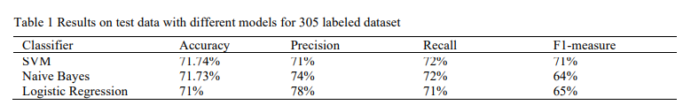
Figure 1 Results on test data for 305 labelled datasets.
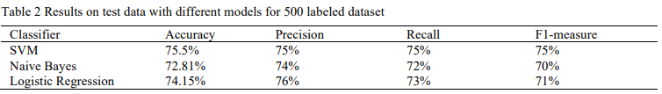
Figure 2 Results on test data for 500 labelled datasets
Experimental results show that Support Vector Machines achieve the highest classification performance, with accuracy improving from approximately 71% on smaller datasets to about 75% on larger datasets. Logistic Regression produces comparable results, while Naive Bayes generally performs worse due to its strong independence assumptions. Feature-level evaluation indicates that TF-IDF features outperform sentiment-based and profanity-based features, and that profanity detection alone is insufficient for reliable cyberbullying identification. (Khan, 2022)

Enhancing Cyberbullying Detection: A Comprehensive Framework Using Machine Learning, Deep Learning, and NLP Techniques
Recent studies have evaluated machine learning and deep learning models for multi-class cyberbullying detection using large-scale social media datasets. The work reviewed here uses a Twitter dataset containing 47,602 labelled tweets across six categories and focuses on addressing class imbalance and linguistic complexity. (Lakkshmanan, 2024)
To improve minority class detection, synthetic oversampling techniques were applied during preprocessing. Models were trained using semantic Word2Vec embeddings and evaluated with standard metrics including accuracy, precision, recall, F1-score, confusion matrices, and ROC–AUC. (Patel, 2025)
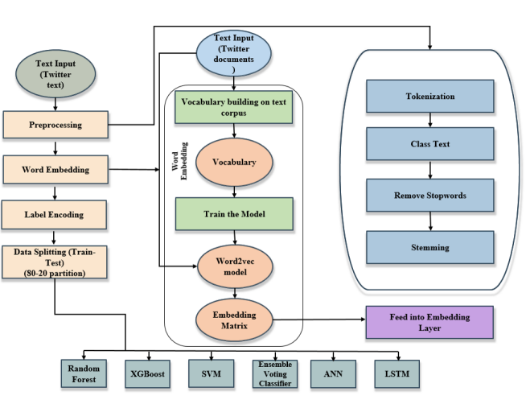
Figure 3:Flowchart illustrating the methodology for cyberbullying detection
Among the evaluated models, the Ensemble Voting Classifier achieved the highest accuracy of 92 percent, outperforming individual classifiers such as SVM and XGBoost, which achieved accuracies of approximately 84 percent. Random Forest showed lower accuracy (78 percent), while Artificial Neural Networks recorded the weakest performance at 80 percent. The LSTM model achieved a high F1-score of 0.99, indicating strong recall for context-dependent cyberbullying, though with slightly reduced overall accuracy.
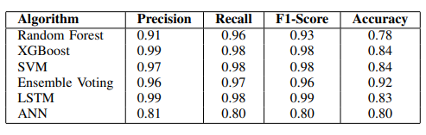
Figure 4:Performance of Different Classifiers
Class-wise analysis showed strong performance for explicit abuse categories such as age, ethnicity, and religion, with precision and recall exceeding 95 percent. In contrast, the non-cyberbullying category exhibited low precision (60 percent), indicating frequent false positives. Confusion matrix and ROC–AUC analysis confirmed overlap between neutral and weakly abusive content. (Yadav, 2020)
The results demonstrate that ensemble learning provides the most stable classification performance, while sequence-based models improve recall but struggle with class ambiguity, highlighting the need for more context-aware representations.

Cyberbullying Detection using Deep Learning Algorithms
Classical machine learning approaches such as Support Vector Machines and Logistic Regression have shown stable performance in cyberbullying detection when combined with TF-IDF features, achieving accuracy levels of approximately 71–75% on Twitter datasets. These results demonstrate that feature-based classifiers are effective for high-dimensional text data but remain limited in capturing deeper contextual and sequential language patterns. (Bhat, 2022)
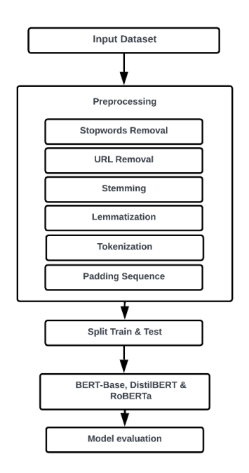
Figure 5:Proposed System Architecture
To address these limitations, later studies introduced deep learning models that learn contextual representations directly from text. Reported results show that LSTM-based models achieved accuracy values as high as 95.59% in binary classification, while CNN models performed best for multi-class cyberbullying classification with accuracy around 78.75% on large tweet datasets. Other LSTM-based approaches achieved accuracies above 96% on Twitter data, outperforming traditional classifiers across multiple platforms including Instagram and Facebook. These findings indicate that deep learning models significantly improve detection performance, particularly for context-dependent cyberbullying content. However, the reported studies also highlight increased computational cost and reliance on large, labelled datasets. This trade-off motivates hybrid approaches that combine the efficiency of classical machine learning with the representational strength of deep learning models. (Sathya, 2024)
Deep learning models improve contextual understanding and recall by modelling sequential dependencies in text. However, these approaches typically require large, labelled Cyberbullying Detection using Pre-Trained BERT Model datasets, involve higher computational cost, and offer limited transparency in their decision-making process. Many studies prioritise predictive performance while giving little attention to interpretability or deployment feasibility. This project responds to these limitations by jointly evaluating model performance, interpretability, and computational efficiency within a unified experimental framework.

Background research

Advanced Cyberbullying Detection: A Hybrid Model Integrated with Naïve Bayes
The study addresses the growing issue of cyberbullying on social media platforms and proposes a machine learning-based approach for detecting abusive content. The methodology combines TF-IDF for text feature extraction with the Naive Bayes classifier to differentiate between cyberbullying and non-bullying messages.
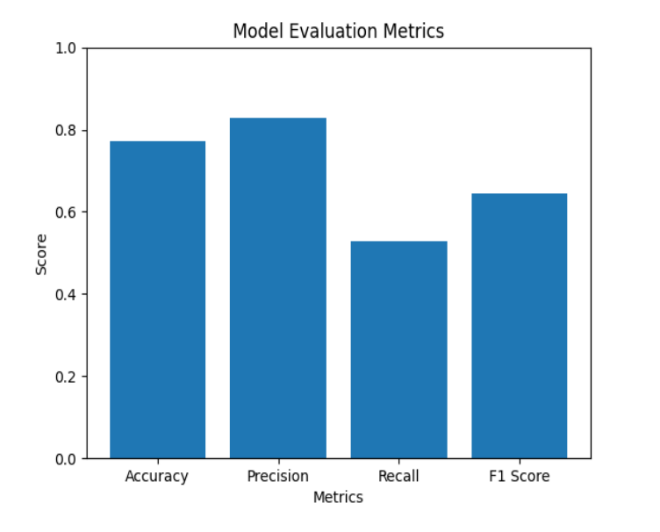
Figure 6 evaluation metrics
The evaluation results indicate an overall classification accuracy of approximately 80 percent across all categories. A precision score close to 0.8 shows that predicted cyberbullying instances are largely correct. However, the recall score of around 0.6 suggests that a notable portion of actual cyberbullying cases remains undetected. The F1 score of approximately 0.7 represents a reasonable balance between precision and recall, while also highlighting limitations in identifying all genuine bullying content. The findings demonstrate that the combination of TF-IDF and Naive Bayes serves as a reliable baseline for automated cyberbullying detection and contributes toward safer online communication environments. (Mathur, 2023)

Effective Automatic Cyberbullying Detection Using a Hybrid Approach SVM And NLP
The research focuses on automatic cyberbullying detection in online text using machine learning and natural language processing techniques. The approach integrates text preprocessing methods with TF-IDF for feature weighting and the LIWC2 tool to capture linguistic and psychological characteristics associated with cyberbullying. A Support Vector Machine classifier is used to separate cyberbullying content from non-cyberbullying text. The study also includes a comparative evaluation against other models such as Random Forest, Recurrent Neural Networks, and Convolutional Neural Networks to assess relative performance.
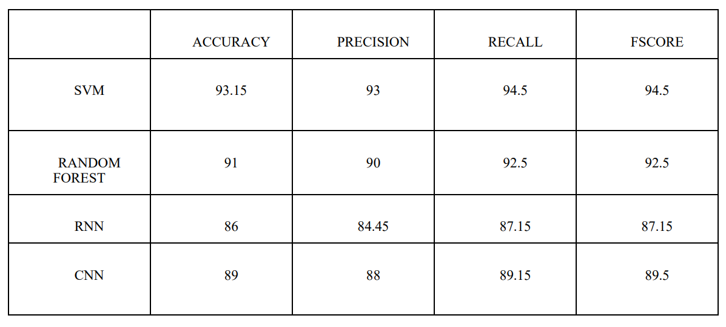
Figure 7:Results Value of All Models
The experimental results show that the SVM-based approach achieves strong classification performance, with an accuracy of 93.15 percent. Precision is reported at approximately 93 percent, indicating reliable identification of bullying content, while recall reaches 96 percent, showing effective detection of most actual cyberbullying instances. The F1 score of 94.5 percent reflects a strong balance between precision and recall. Comparative analysis demonstrates that the SVM model outperforms the other evaluated classifiers across accuracy, precision, recall, and F1 score. The findings indicate that combining TF-IDF, LIWC2, and SVM provides an effective method for cyberbullying detection and supports the development of real-time monitoring tools for online platforms.

A Study on Automatic Detection of Cyberbullying using Machine Learning
The study reviews existing research on cyberbullying detection in online and social media environments, focusing on machine learning and natural language processing approaches. The work analyses multiple research papers to understand commonly used feature extraction techniques and classification models for automatic cyberbullying detection. Attention is given to the use of TF-IDF for converting textual data into numerical feature vectors, as TF-IDF appears frequently across reviewed studies either as a standalone technique or in combination with other methods. (Mathew, 2025)
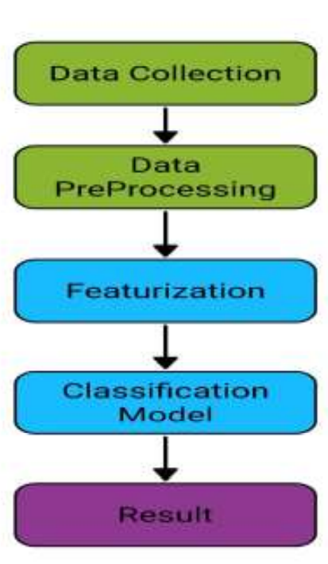

Figure 8 :Diagram for general steps of cyberbullying detection.
The findings also show a growing interest in combining feature extraction techniques with advanced models to improve performance. The study concludes by identifying deep learning approaches as a potential direction for future research, suggesting that neural network-based models may further enhance the effectiveness of cyberbullying detection systems.

Cyberbullying Detection using Pre-Trained BERT Model
The study investigates cyberbullying detection on social media platforms using a deep learning approach based on the pre-trained BERT language model. The proposed method applies contextual word embeddings generated by BERT, followed by a single linear neural network layer for classification of bullying and non-bullying content. The model is trained and evaluated on two social media datasets, namely Form spring and Wikipedia, to analyse performance across datasets of different sizes. Oversampling techniques are applied to the Form spring dataset to address class imbalance, while no oversampling is used for the larger Wikipedia dataset. (Vyawahare, 2022)
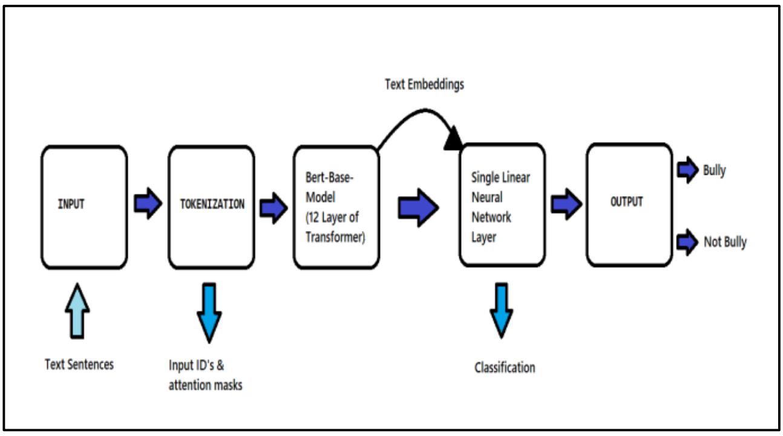
Figure 9 :Architecture Overview
Results show that oversampling bullying instances significantly improves performance, with the F1 score on the Form spring dataset rising from 0.59 to 0.94, while BERT achieves strong results on the larger Wikipedia dataset even without oversampling. Overall, the BERT-based model outperforms traditional and deep learning baselines, reaching up to 98% accuracy on Form Spring and 96% on Wikipedia. Despite their effectiveness, transformer models are computationally expensive, so this study systematically compares them with well-optimised classical models under identical conditions to provide a fair evaluation.

Cyberbullying Detection using Deep Learning
The study examines the use of machine learning and deep learning models for detecting cyberbullying across online platforms. Several neural network architectures are evaluated, including LSTM, GRU, and the transformer-based BERT model, along with different text representation techniques such as Word2Vec, GloVe, and contextual embeddings. The analysis focuses on comparing sequential models and transformer models to determine their ability to capture linguistic context, semantic meaning, and interpretive cues present in abusive online text.
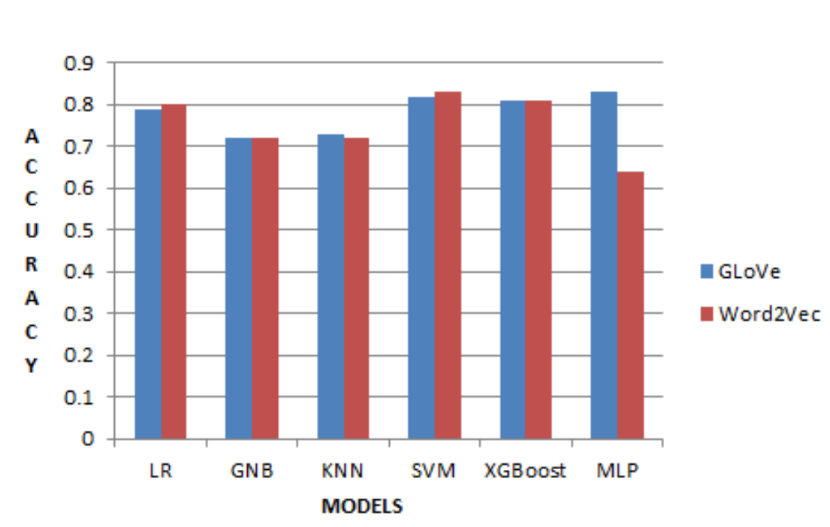
Figure 10 Accuracy Comparison Chart
The results show that deep learning models outperform traditional classifiers for cyberbullying detection. Among recurrent models, GloVe-based LSTM and GRU perform better than their Word2Vec variants, while BERT achieves the best overall performance with around 97 percent accuracy. These findings demonstrate the strength of transformer-based models in capturing complex contextual and implicit abuse, and suggest future work in areas such as temporal modelling, multilingual detection, few-shot learning, and real-time deployment. (Toktarova, 2024)

Comparative Summary of Cyberbullying Detection Studies

Study Focus | Dataset | Feature Extraction | Model(s) Used | Reported Performance | Verified Key Findings
Binary cyberbullying detection | Social media data | TF-IDF | Naive Bayes | Accuracy ≈ 80%, F1 ≈ 0.7 | High precision, lower recall; suitable as a baseline approach
Cyberbullying detection with linguistic features | Real-world social media data | TF-IDF, LIWC2 | SVM | Accuracy = 93.15%, Precision = 0.93, Recall = 0.96 | Linguistic and psychological features significantly improve performance
Survey and review of ML approaches | Multiple prior studies | TF-IDF (dominant) | Logistic Regression, SVM, NB | LR reported to perform better in some studies | TF-IDF is the most used feature extraction method
Transformer-based cyberbullying detection | Form spring, Wikipedia | BERT contextual embeddings | BERT + Linear Layer | Accuracy up to 98% | Oversampling improves performance on small datasets; strong results on large datasets
Comparison of DL models | Twitter | Word2Vec, GloVe, BERT | LSTM, GRU, BERT | Accuracy ≈ 97% (BERT) | BERT outperforms RNN-based models in capturing context
Supervised ML for cyberbullying (2023) | Twitter | TF-IDF, sentiment, profanity | SVM, Logistic Regression, Naive Bayes | Accuracy ≈ 75% (SVM) | TF-IDF outperforms sentiment and profanity features
Multi-class cyberbullying detection | Twitter (47,602 tweets) | Word2Vec | SVM, XGBoost, RF, ANN, LSTM, Ensemble Voting | Accuracy ≈ 92% (Ensemble), F1 ≈ 0.99 (LSTM) | Ensemble models provide stable accuracy; LSTM improves recall
Table 1 Comparative Summary of Cyberbullying Detection Studies
The literature shows a clear progression from traditional machine learning models to deep learning and transformer-based approaches, with an increasing focus on contextual understanding. Early methods using TF-IDF with classifiers such as Naive Bayes, Support Vector Machines, and Logistic Regression achieved moderate performance and mainly served as baseline solutions. The inclusion of linguistic and psychological features improved detection accuracy, demonstrating the value of richer text representations. Deep learning models such as LSTM and GRU further enhanced performance, particularly recall, but transformer-based models, especially BERT, consistently outperformed earlier approaches, achieving accuracies above 95 percent on large datasets. Despite these advances, most studies lack direct comparisons across model families and give limited attention to severity estimation, explainability, and deployment, which motivates the integrated approach adopted in this project.

CHAPTER 3

Ethical, Legal, Professional, and Social Considerations

Ethical Considerations
Ethical responsibility is important when working with cyberbullying detection and toxicity analysis, especially when using data from online platforms. Although the datasets used in this project are publicly available, they were handled carefully to avoid misuse.
All text data was treated anonymously, and no attempt was made to identify individual users. Information such as usernames, profile details, or location data was not included. This ensured that user privacy was protected throughout the study.
To prevent incorrect labelling of harmless content, attention was given to model interpretability and prediction behaviour. Explainable techniques were used to support responsible use and minimise potential harm.

Legal Considerations
Even when using publicly available online data, legal responsibilities must be followed. Guidelines from regulations such as the General Data Protection Regulation (GDPR) and the Information Technology Act, 2000, were considered during the project. While direct user consent is not always required for public data, ethical handling of such data remains essential.
The project aligns with legal efforts to address online harassment without limiting lawful expression or freedom of speech. The analysis was designed to be non-intrusive and not to encourage discriminatory or punitive actions. (Saha, 2023)
Intellectual property guidelines were also respected. All datasets, libraries, and tools were used according to their licenses and properly acknowledged, ensuring legal and academic integrity.

Professional Considerations
High professional standards were maintained throughout the project to ensure reliability and credibility. The methodology followed accepted practices in machine learning and cybersecurity research, focusing on accuracy and robustness.
Regular evaluation helped identify limitations and guided improvements. Clear documentation was maintained to support reproducibility and future research. The project also openly acknowledges limitations related to data quality, bias, and generalization, rather than overstating performance, which supports responsible research practice.

Social Considerations
Cyberbullying detection has important social implications, especially in online spaces where free expression is important. Automated tools can help create safer digital environments, but they must be used carefully to avoid unnecessary censorship.
The automated analysis developed in this project is intended to support human judgment, not replace it. This approach helps ensure that context is considered and that legitimate communication is not unfairly restricted. (Mahmud, 2022)
Beyond detection, the project aims to raise awareness about cyberbullying and promote respectful online behaviour. By improving understanding of harmful language patterns, it contributes to building safer and more inclusive online communities.

Laptop Hardware and Software Specifications
Component | Description
Device | MacBook Air (13-inch, 2017 edition)
Operating Platform | macOS Monterey, version 12.7.6
Processor | Intel Core i5 dual-core processor running at 1.8 GHz
System Memory | 8 GB DDR3 RAM operating at 1600 MHz
Storage Drive | Macintosh HD
Graphics Unit | Intel HD Graphics 6000 with 1536 MB shared memory
Table 2 Laptop Hardware and Software Specifications


Figure 11 Laptop Hardware and Software Specifications snap

Software Requirements
Category | Tools and Technologies Used
Development Environment | Jupyter Notebook
Programming Language | Python
Data Handling | Pandas, NumPy
Text Processing | Natural Language Toolkit (NLTK)
Machine Learning Framework | Scikit-learn
Model Interpretation | SHAP, LIME
Feature Engineering | TF-IDF Vectorizer
Model Deployment | Streamlit
Utility Tools | Joblib
Data Visualization | Matplotlib, Seaborn
Evaluation Metrics | Accuracy, Precision, Recall, F1-Score, Mean Absolute Error (MAE), Root Mean Squared Error (RMSE), R² Score
Table 3 Software Requirements

Overview of the Methodological Framework
This study adopts a structured machine learning approach to analyse cyberbullying and textual toxicity in social media text. The methodology consists of data preprocessing, feature extraction, model training, evaluation, and deployment.
Two main tasks are addressed: cyberbullying type classification and toxicity intensity prediction. Cleaned text data is transformed into numerical features using TF-IDF and used to train supervised learning models. Model explainability techniques are applied to interpret predictions, and the trained models are deployed through a web application for real-time analysis and visual explanation.

Dataset Description
Data Sources
The CYBY23 dataset was derived from the Cyber Bystander corpus introduced in the study “Bystanders Unveiled: Introducing a Comprehensive Cyberbullying Corpus with Bystander Information.” (Haifa Saleh, 2023) This dataset was developed to support research on cyberbullying, aggression, and bystander behaviour in online environments. It contains text data annotated by human annotators with multiple toxicity-related and aggression-related scores, making it suitable for regression-based analysis of harmful language severity.
The cyberbullying tweets dataset consists of Twitter posts labelled into different cyberbullying categories and is commonly used in cyberbullying detection research. Each instance includes the tweet text and a corresponding class label, allowing supervised multi-class classification. The dataset focuses on identifying different forms of cyberbullying in short social media text, reflecting realistic online communication patterns.
Both datasets were collected from social media platforms and annotated manually, ensuring reliability and relevance for supervised learning. Their complementary structure supports both categorical cyberbullying detection and continuous toxicity prediction, aligning well with the objectives of this study.
Data Preprocessing
Text preprocessing is carried out to convert raw tweet content into a clean and consistent format suitable for machine learning models. The same preprocessing logic is applied across both classification and regression tasks to maintain uniformity.
All text is first converted to lowercase. URLs, user mentions, hashtags, digits, punctuation, and special characters are removed to reduce noise. Extra whitespace is normalised, and empty inputs are handled safely to avoid runtime errors. (Daniel, 2022)
Stop word removal and lemmatization are then applied to retain only meaningful base words, which helps improve feature quality and reduces dimensionality.
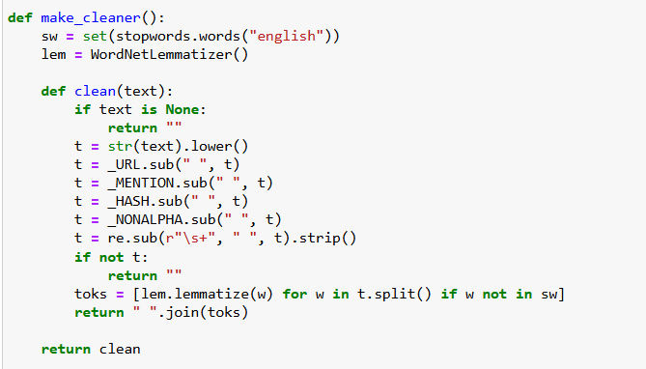
Figure 12 Data Preprocessing
After cleaning, the processed text is converted into numerical features using the TF-IDF representation. This step transforms textual data into vectors that can be used for training supervised learning models.
This preprocessing pipeline ensures that the input data is clean, consistent, and suitable for both classification and multi-output regression tasks.
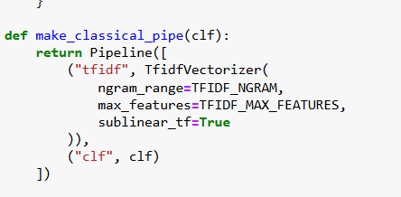
Figure 13 TF-IDF representation
Exploratory Data Analysis for Cyberbullying Type Classification
Exploratory analysis was performed to understand the characteristics of the cyberbullying classification dataset and to validate its suitability for supervised learning.
The class distribution analysis shows that the dataset is well balanced across all categories, including religion, age, gender, ethnicity, and not cyberbullying. Each class contains a similar number of samples, which helps prevent model bias towards any specific category and supports fair performance comparison across classes.
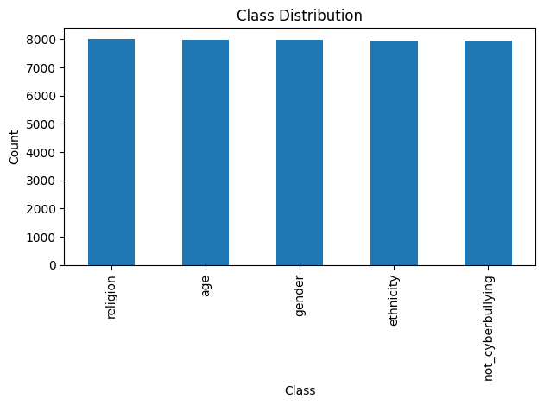
Figure 14 The class distribution
Analysis of raw tweet length indicates that most tweets are short, with most texts falling within a limited character range. A small number of longer tweets are also present, reflecting natural variation in user-generated content. After preprocessing, the cleaned tweet length distribution shows a clear reduction in character count, confirming that noise such as URLs, symbols, and unnecessary text has been effectively removed.

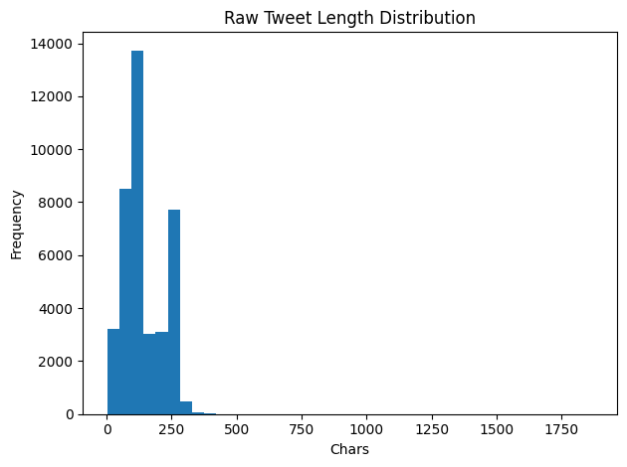
Figure 15 Analysis of raw tweet length
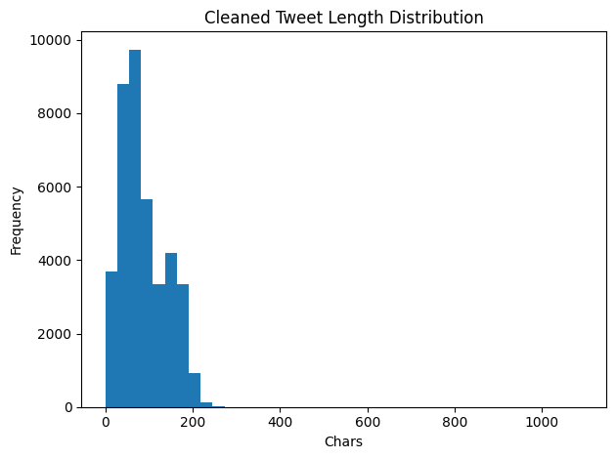
Figure 16 Analysis of clean tweet length
Token count analysis on cleaned text reveals that most tweets contain a manageable number of meaningful words. This confirms that TF-IDF feature extraction is appropriate, as the vocabulary size remains controlled and informative.
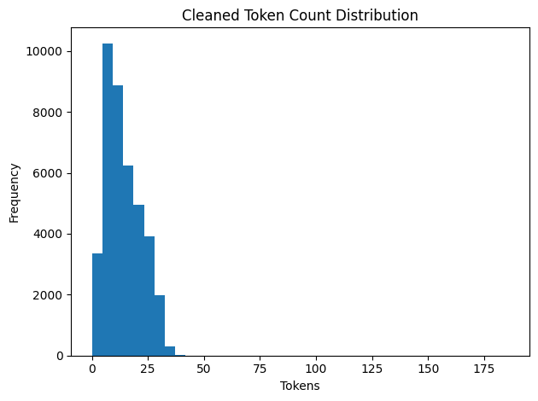
Figure 17 Cleaned token count distribution
Frequent token analysis highlights commonly occurring words related to abuse, identity, and social references. The presence of such terms supports the relevance of the dataset for learning cyberbullying patterns. At the same time, neutral and contextual words are also observed, which helps the model differentiate between abusive and non-abusive content.
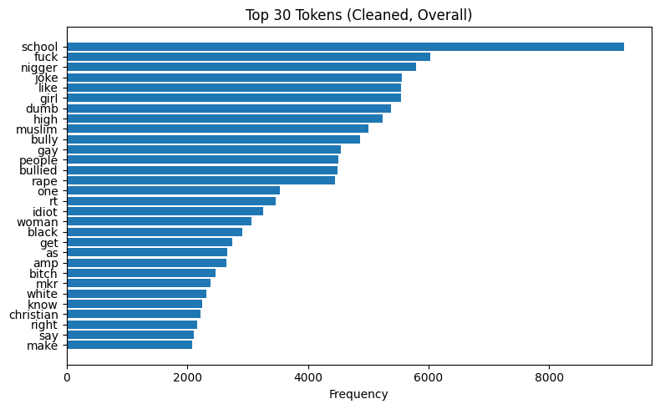
Figure 18 Top 30 tokens {cleaned}
The exploratory analysis confirms that the dataset is suitable for supervised learning, with balanced class representation and controlled text length after preprocessing. The presence of both abusive and neutral tokens indicates that classification requires contextual discrimination rather than simple keyword matching. These observations justify the use of TF-IDF feature representation combined with supervised classifiers and explain the need for models capable of handling overlapping linguistic patterns.
The impact of preprocessing is further illustrated through raw-to-clean text examples. Hashtags, mentions, and irrelevant symbols are removed, while meaningful words are retained in their lemmatized form. This transformation improves text clarity and ensures that the model focuses on semantic content rather than formatting noise.
The exploratory analysis confirms that the dataset is balanced, the text length is suitable for vector-based representation, and the preprocessing steps effectively enhance feature quality for cyberbullying type classification.
Exploratory Data Analysis for Toxicity Intensity Prediction
Exploratory analysis was conducted to understand the distribution and behaviour of toxicity-related target variables used for regression. The dataset includes continuous scores for multiple attributes such as insult, threat, identity attack, profanity, overall toxicity, and severe toxicity.
Histogram analysis shows that most toxicity attributes are skewed towards lower values, indicating that a large portion of the data contains mild or non-toxic content. Higher toxicity values occur less frequently, reflecting the natural imbalance present in real-world social media data. This pattern is consistent across attributes such as threat and severe toxicity, where extreme values are relatively rare.
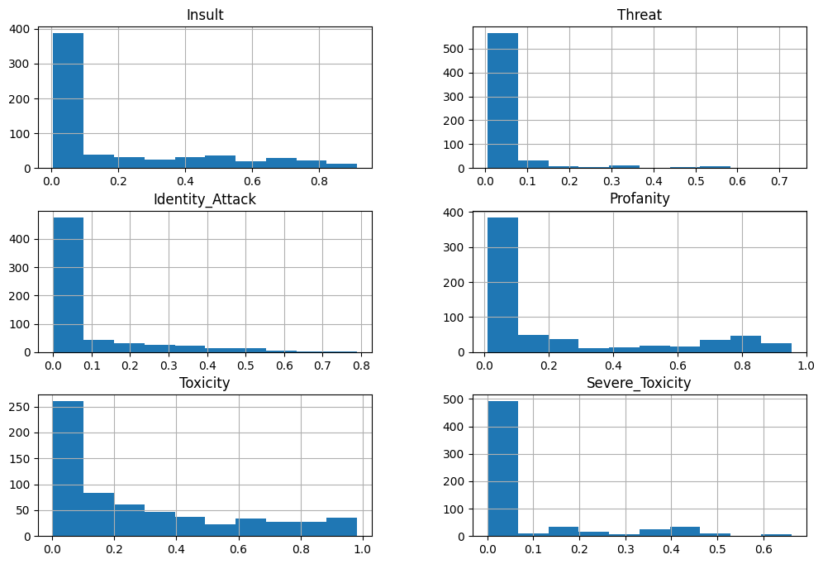
Figure 19 Exploratory Data Analysis for Toxicity Intensity Prediction
The profanity and overall toxicity scores display a wider spread, suggesting greater variability in offensive language usage. This supports the use of a regression-based approach rather than binary classification, as toxicity intensity varies continuously across samples. (Zotkina, 2024)
A scatter plot comparing toxicity scores with retweet count shows no strong linear relationship. Most tweets, regardless of toxicity level, receive low engagement, while a few highly toxic tweets show unusually high retweet counts. This indicates that engagement is influenced by factors beyond toxicity alone.
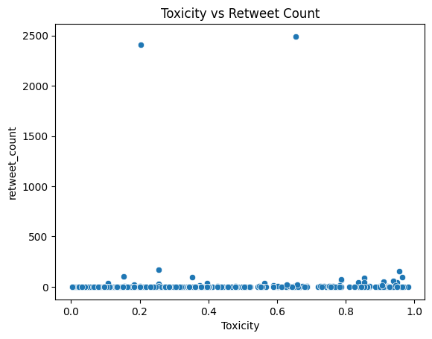
Figure 20 Toxicity vs Retweet Count
The skewed distribution of toxicity scores indicates that most samples exhibit low to moderate toxicity, with relatively few extreme cases. This imbalance explains the difficulty observed in predicting certain attributes such as threat and severe toxicity during regression. The absence of a strong relationship between toxicity and engagement further suggests that toxicity intensity must be inferred primarily from textual content rather than external interaction signals.
Sample inspection of high-toxicity texts confirms that extreme values correspond to strongly abusive and explicit language. These observations validate the reliability of the target labels and their alignment with real-world interpretations of toxic content.
The exploratory analysis confirms that the regression dataset contains meaningful variation across multiple toxicity dimensions and is suitable for multi-output regression modelling.
Despite their usefulness, the datasets used in this project contain inherent limitations and biases. Twitter data may not fully represent language patterns from other platforms such as forums or private messaging applications. Cultural, linguistic, and contextual biases may also be present due to the demographic composition of users and annotation guidelines. In the toxicity dataset, certain attributes such as threat and severe toxicity are relatively sparse, which contributes to reduced regression performance for these targets. These factors may limit generalisation and should be considered when interpreting results.

Cyberbullying Type Classification Methodology
The cyberbullying detection task is formulated as a multi-class text classification problem, where each input tweet is assigned to one of five categories: age-based, gender-based, religion-based, ethnicity-based, or not cyberbullying. The objective is to learn linguistic patterns that distinguish abusive content from non-abusive content and to further identify the specific type of cyberbullying.
After preprocessing, textual data is converted into numerical features using the Term Frequency–Inverse Document Frequency (TF-IDF) technique. TF-IDF is selected due to its effectiveness in representing short text data and its suitability for classical machine learning models operating on high-dimensional sparse features.
Classical Machine Learning Models
Multiple supervised learning algorithms are trained and evaluated to identify the most suitable classifier:
- Logistic Regression is used as a baseline model due to its simplicity, efficiency, and strong performance in text classification tasks.
- Random Forest Classifier is employed to capture non-linear relationships between textual features through an ensemble of decision trees.
- Multinomial Naive Bayes is included as it is specifically designed for word frequency-based text representations.
- Linear Support Vector Classifier (Linear SVC) is applied for its effectiveness in handling high-dimensional sparse data using a maximum-margin approach.
- Ridge Classifier is used as a regularised linear model to reduce overfitting and improve generalisation.
All models are trained using an 80:20 train–test split and evaluated using accuracy and F1-score. The best-performing classical model is selected and saved for deployment.
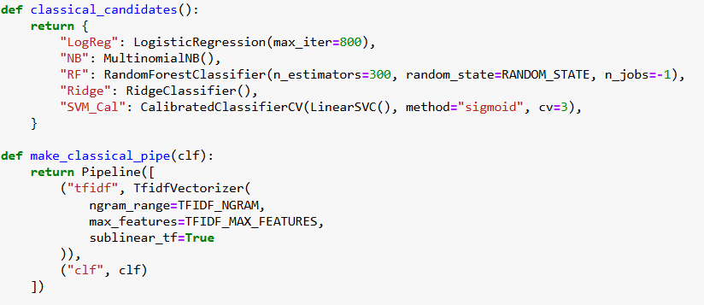
Figure 21 Classical Machine Learning Models
Transformer-Based Model (DistilBERT)
In addition to classical models, a DistilBERT-based transformer model is integrated at the deployment stage for cyberbullying classification. DistilBERT is a lightweight version of BERT that retains strong contextual understanding while being computationally efficient.
Unlike TF-IDF-based models, DistilBERT operates directly on raw text and captures contextual relationships between words. In the web application, DistilBERT is loaded conditionally when the required model files and dependencies are available. If unavailable, the application automatically falls back to the best-performing classical model.
This hybrid approach combines the efficiency and interpretability of classical models with the contextual strength of transformer-based models, improving flexibility and robustness during real-time prediction.
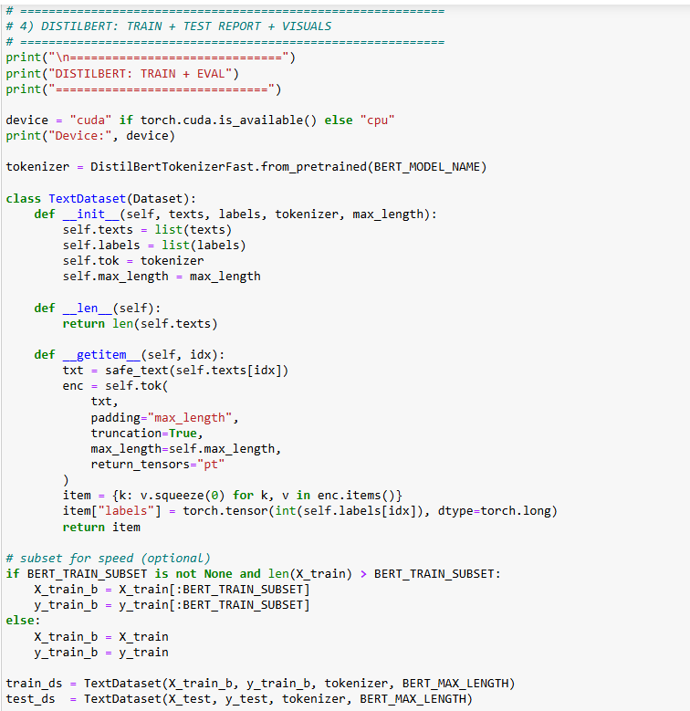
Figure 22 Transformer-Based Model (DistilBERT)
Toxicity Intensity Prediction Methodology
The toxicity prediction task is formulated as a multi-output regression problem, where a single input tweet is used to predict multiple toxicity-related scores simultaneously. These scores include insult, threat, identity attack, profanity, overall toxicity, and severe toxicity. Each target variable represents a continuous value, reflecting the intensity of toxicity rather than a binary outcome. (Teng, 2023)
Like the classification task, the input text is first pre-processed and transformed into numerical features using the TF-IDF representation. Using the same feature extraction technique ensures consistency across tasks and allows the models to learn meaningful word importance patterns related to toxic language.
Multiple regression models are trained and evaluated to compare their effectiveness in predicting toxicity scores:
- Linear Regression is used as a baseline model to establish a simple relationship between text features and toxicity values. It provides interpretability and helps assess whether linear patterns exist in the data.
- Random Forest Regressor is employed to capture complex and non-linear relationships between textual features and toxicity intensity. Its ensemble structure improves robustness and handles feature interactions effectively.
- Gradient Boosting Regressor is used to incrementally improve prediction accuracy by correcting errors made by previous models. This model is well suited for structured prediction tasks involving continuous targets.
- K-Nearest Neighbours Regressor is included to explore instance-based learning, where toxicity scores are predicted based on similarity to neighbouring samples in the feature space.
- Multi-layer Perceptron Regressor is applied to model non-linear patterns using a neural network-based approach, allowing the model to learn higher-level feature interactions.
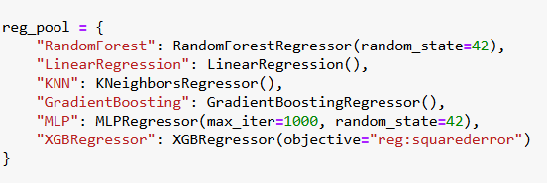
Figure 23 Multiple regression models are trained and evaluated
Since multiple toxicity attributes are predicted together, each regression model is wrapped using a Multioutput Regressor, enabling simultaneous prediction of all target variables using a shared input representation.
All regression models are trained using an 80:20 train–test split. Performance is evaluated using Mean Squared Error (MSE) and R-squared (R²) metrics for each output variable. The best-performing regression model is selected based on overall predictive accuracy and stability and is saved for use during deployment.
This regression methodology allows fine-grained estimation of toxicity levels, providing deeper insight into the severity of harmful language beyond simple classification.
Model Explainability Techniques
Model explainability is incorporated to improve transparency and understanding of prediction behaviour, especially for sensitive tasks such as cyberbullying detection and toxicity analysis. Instead of relying only on performance metrics, explainability methods are used to identify which words in the text influence model predictions.
For the classification task, two model-agnostic explainability techniques are applied: LIME and SHAP. These methods operate independently of the underlying model and can be applied to any trained classifier.
LIME (Local Interpretable Model-Agnostic Explanations) is used to generate local explanations for individual predictions. It works by slightly modifying the input text and observing how the prediction changes. Based on this behaviour, LIME highlights the most influential words contributing to the predicted class. (Elankavi, 2024)
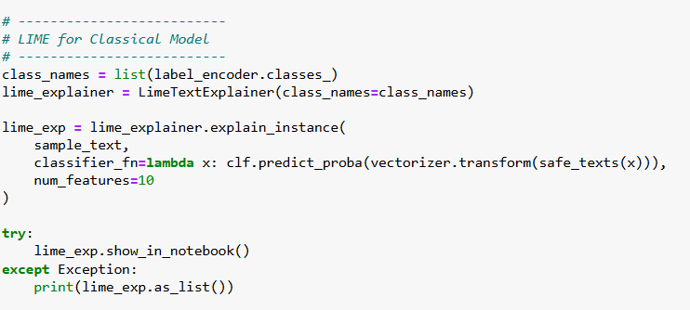
Figure 24 LIME (Local Interpretable Model-Agnostic Explanations)
SHAP (Shapley Additive explanations) is used to compute feature contribution scores based on cooperative game theory. SHAP assigns an importance value to each word, indicating its positive or negative impact on the final prediction. This provides a clear visual explanation of how different tokens influence the model decision.
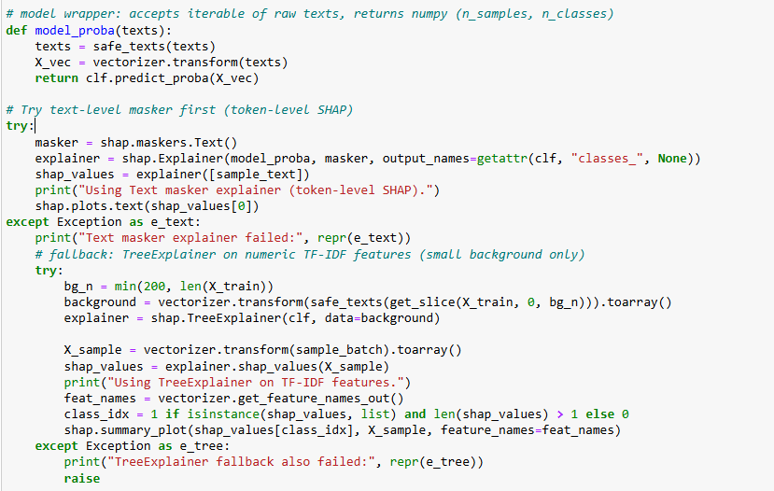
Figure 25 SHAP (Shapley Additive explanations)
Explainability is applied only to the classification models, as these outputs are categorical and benefit most from word-level interpretation. Toxicity regression outputs are presented numerically without explainability visualisation.
By integrating explainability techniques, the methodology ensures that model predictions are interpretable, transparent, and suitable for responsible analysis of harmful online content.
Model Evaluation
Model evaluation is performed to assess the performance and reliability of both the cyberbullying classification models and the toxicity regression models. Separate evaluation strategies are adopted for classification and regression tasks, based on the nature of their outputs.
Evaluation of Cyberbullying Classification Models
For the classification task, model performance is evaluated using standard classification metrics. Accuracy is used to measure overall correctness, while the F1-score is used to evaluate class-wise prediction quality by balancing precision and recall. These metrics help ensure that the models perform consistently across all cyberbullying categories.
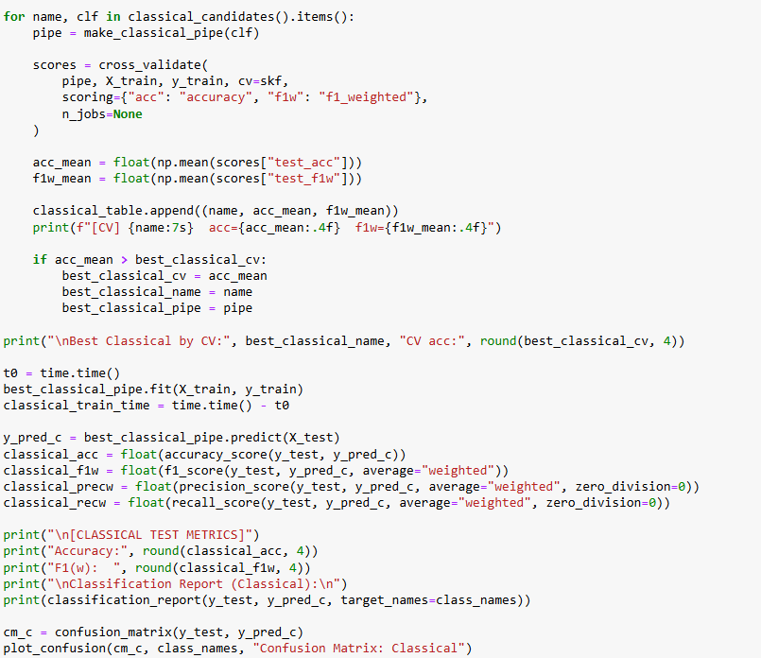
Figure 26Evaluation of Cyberbullying Classification Models
All classification models are evaluated on the test set created using an 80:20 train–test split. The evaluation results are compared to identify the most effective model for cyberbullying type prediction.
Evaluation of Toxicity Regression Models
For the toxicity prediction task, regression-based evaluation metrics are applied. Mean Squared Error (MSE) is used to measure the average squared difference between predicted and actual toxicity values. The R-squared (R²) score is used to assess how well the model explains the variance in each toxicity attribute.
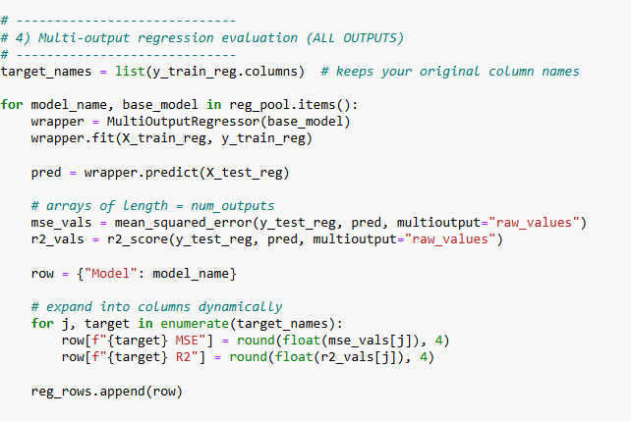
Figure 27 Evaluation of Toxicity Regression Models
Since multiple toxicity scores are predicted simultaneously, evaluation is performed separately for each output variable. This provides a detailed understanding of model performance across different toxicity dimensions.
The regression model with the most stable and accurate performance across outputs is selected for deployment.
Model Persistence and Reusability
After model training and evaluation, the selected models are saved to enable reuse during deployment without the need for retraining. This ensures consistency between the training phase and the prediction phase.
The trained TF-IDF vectorizers and the final classification and regression models are stored using the joblib library. Saving the vectorizer is necessary to preserve the feature space learned during training, ensuring that new text inputs are transformed in the same way as the training data.
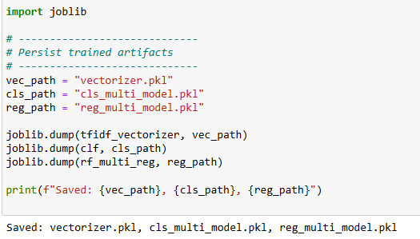
Figure 28 Model Persistence and Reusability
During deployment, these saved files are loaded directly into the application. This allows real-time predictions to be generated using the same preprocessing, feature extraction, and model parameters as used during training.
Model persistence improves efficiency, reduces computational cost, and supports reproducibility. It also enables seamless integration of the trained models into the web application for real-time cyberbullying detection and toxicity prediction.
Web Application Deployment
The trained models are deployed through a Streamlit-based web application that supports real-time cyberbullying classification and toxicity prediction. User input is pre-processed consistently with the training pipeline, transformed using saved TF-IDF vectorizers, and evaluated using loaded classification and regression models. The application displays predicted classes, probability scores, and toxicity values, with LIME and SHAP providing explainable insights into predictions. This deployment demonstrates the practical usability of the proposed system for real-time text analysis.

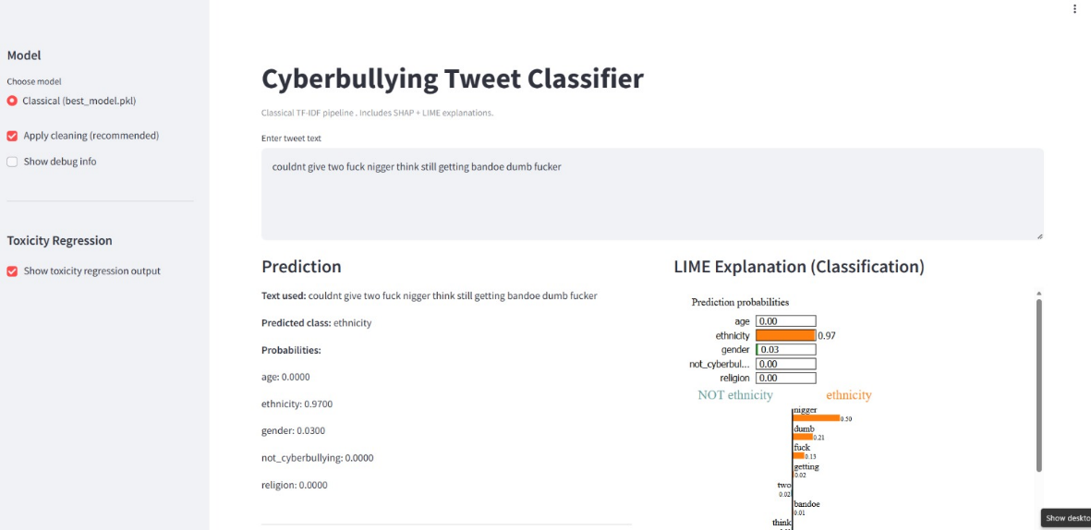
Figure 29 Web Application Deployment 1
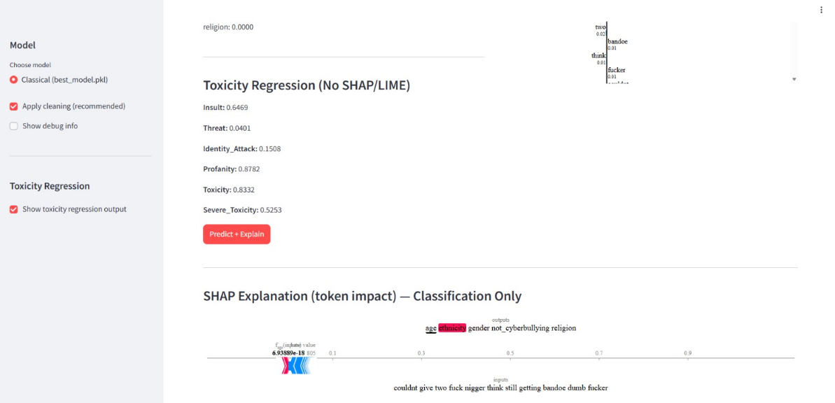
Figure 30 Web Application Deployment 2
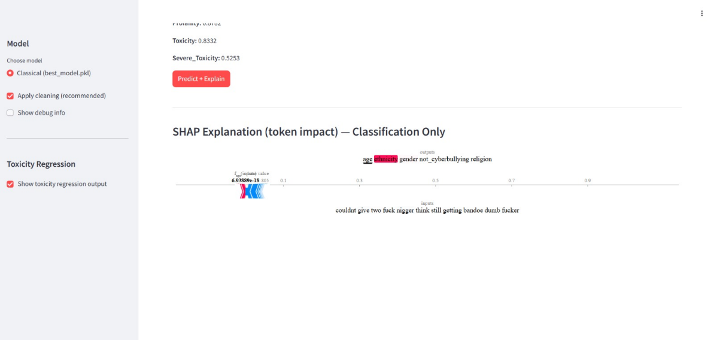
Figure 31 Web Application Deployment 3

CHAPTER 4

Project Journey, Challenges faced and Learning Outcomes

Project Journey
The project started with the objective of analysing cyberbullying in online text using machine learning techniques. The initial phase involved understanding the problem domain, reviewing existing approaches, and identifying suitable datasets. Since text data often contains noise, significant effort was spent on data cleaning and preprocessing.
After preprocessing, traditional machine learning models were implemented for classification and regression tasks. These models were selected to establish a clear baseline and to understand their behaviour on textual data. A transformer-based model, DistilBERT, was later introduced to compare its classification performance with traditional models.
In the later stages of the project, focus shifted towards presenting the results in an interactive manner. A web-based application was developed using Streamlit to allow users to enter text and view classification results, toxicity predictions, and explanation outputs. This phase helped connect model development with practical usage.

Challenges Faced
Dependency Issues with DistilBERT
One of the major challenges faced during the project was related to dependency management while working with DistilBERT. The model required specific versions of libraries such as PyTorch and Transformers. Mismatched versions led to installation errors and runtime issues, which slowed down experimentation.
Resolving these issues required careful management of the development environment and an understanding of library compatibility. This challenge highlighted the additional complexity involved in using transformer-based models.
Difficulty in Model Selection
Another challenge was deciding which machine learning models to use for classification and regression tasks. Initially, there was uncertainty about whether to focus on complex models or simpler ones. Testing multiple models without a clear direction increased development time.
This issue was addressed by first selecting traditional models as the main approach and then using DistilBERT only for comparison. For toxicity prediction, regression models capable of predicting multiple outputs were chosen based on project requirements. This decision helped maintain clarity and structure in the implementation.
Learning Streamlit for Application Development
Developing the web-based application using Streamlit presented a learning challenge. While machine learning concepts were familiar, building an interactive interface required learning new ideas such as layout design, user input handling, and model loading.
Additional effort was required to integrate explanation outputs from SHAP and LIME into the interface in a readable format. Through experimentation and testing, these challenges were gradually resolved, resulting in a functional application.

Insights Gained
One important insight gained during the project was that traditional machine learning models can perform effectively when combined with proper text preprocessing. This showed that model performance depends not only on complexity but also on data preparation.
The project also highlighted the value of deployment. Developing a web-based application exposed practical issues such as performance and usability, which are not always visible during offline model training. (Khan, 2024)

Learning Outcomes
The project resulted in several learning outcomes, including:
- Improved understanding of text preprocessing and feature extraction.
- Practical experience with traditional machine learning and transformer-based models.
- Knowledge of regression techniques for predicting toxicity levels.
- Experience in applying explanation methods for model interpretation.
- Skills in developing and deploying a web-based application using Streamlit.
- Improved problem-solving skills through debugging and experimentation. (Kaarthika, 2024)

CHAPTER 5

Introduction to Results
This chapter presents the experimental results obtained from the cyberbullying classification task and the toxicity prediction task. The models were evaluated using standard metrics such as Accuracy, Weighted F1 score, Mean Squared Error (MSE), and R² score, depending on the task. The results are presented using tables to make comparisons clear and to support discussion.
The evaluation was performed in the following parts:
- Comparison of classical machine learning models for cyberbullying classification using cross validation.
- Final evaluation of the best classical model on the test dataset.
- Training and evaluation of DistilBERT for classification comparison.
- Comparison of classification results including training time.
- Toxicity related evaluation using multi label classification and multi output regression.

Cyberbullying Classification Results
Cross Validation Comparison of Classical Models
Several classical machine learning models were trained and compared using cross validation. The evaluation used two metrics for comparison: accuracy and weighted F1 score. The purpose of this step was to identify the best performing classical model before testing on unseen data.
Model | CV Accuracy | CV Weighted F1
Logistic Regression | 0.9276 | 0.9281
Naive Bayes | 0.8632 | 0.8572
Random Forest | 0.9360 | 0.9367
Ridge Classifier | 0.9274 | 0.9277
SVM (Calibrated) | 0.9285 | 0.9286

Table 4:Cross validation performance of classical classification models

Random Forest achieved the highest cross validation accuracy (0.9360) and highest weighted F1 score (0.9367). Therefore, Random Forest was selected as the best classical model for final testing. (Vidart, 2023)

Test Dataset Results for Best Classical Model
Based on the cross-validation results discussed in the previous section, the Random Forest model was selected as the best performing classical classifier, achieving a cross-validation accuracy of 0.936. To evaluate its ability to generalise to unseen data, the model was tested on a separate test dataset containing 7,974 samples (Chowdary, 2024).
Overall Test Performance
The overall performance of the Random Forest model on the test dataset is presented below.
Metric | Value
Accuracy | 0.9396
Weighted F1 Score | 0.9401
Test Samples | 7,974
Table 5 Overall Test Performance
The results show that the model achieved an accuracy of 93.96 percent, which is slightly higher than the cross-validation accuracy. The weighted F1 score closely matches the accuracy value, indicating a good balance between precision and recall across all classes. This consistency suggests that the model generalised well and did not suffer from overfitting.
Class-wise Performance Evaluation
To analyse the performance of the model in more detail, class-wise precision, recall, and F1 score values were examined. These results are summarised in Table 5.3.
Class | Precision | Recall | F1 Score | Support
Age | 0.99 | 0.98 | 0.98 | 1,598
Ethnicity | 0.99 | 0.98 | 0.99 | 1,592
Gender | 0.95 | 0.86 | 0.90 | 1,595
Not Cyberbullying | 0.82 | 0.91 | 0.86 | 1,589
Religion | 0.96 | 0.96 | 0.96 | 1,600
Weighted Average | 0.94 | 0.94 | 0.94 | 7,974
Table 6 Class-wise classification results for the Random Forest model
The age, ethnicity, and religion categories show very strong performance, with precision and recall values close to 1.00. This indicates that the textual patterns related to these forms of cyberbullying are clearly distinguishable and well learned by the model.
The gender category shows slightly lower recall compared to other classes. This indicates that some gender-related cyberbullying instances were misclassified into other categories, particularly the not cyberbullying class. This behaviour can be attributed to overlapping language patterns between gender-related discussions and neutral or contextual text. (Mathew, 2024)
The not cyberbullying class shows high recall but lower precision. This suggests that while most non-cyberbullying samples were correctly identified, some cyberbullying content was incorrectly classified as non-cyberbullying. Such misclassifications are common in text-based tasks where the distinction between harmful and neutral language can be subtle.
Macro and Weighted Average Analysis
To evaluate the effect of class distribution on model performance, macro and weighted average metrics were compared.
Average Type | Precision | Recall | F1 Score
Macro Average | 0.94 | 0.94 | 0.94
Weighted Average | 0.94 | 0.94 | 0.94
Table 7 Macro and Weighted Average Analysis
The similarity between macro and weighted averages indicates that the dataset is relatively balanced and that the model performs consistently across all categories without favouring any class.
Graphical Interpretation
To support the numerical results, the following graphical representations are included:
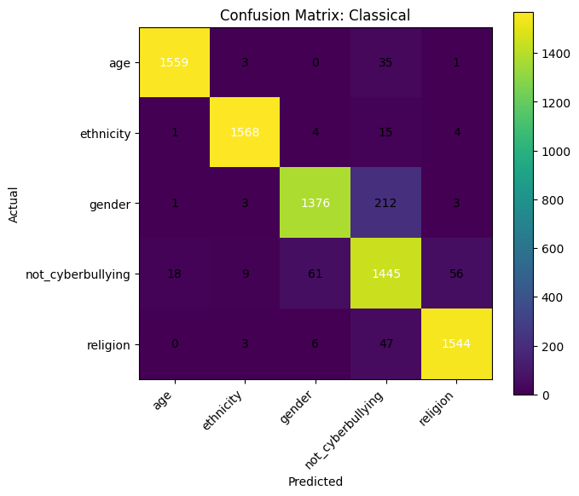
Figure 32 Graphical Interpretation
The confusion matrix highlights strong diagonal dominance, confirming a high number of correct predictions. Misclassifications are primarily observed between the gender and not cyberbullying classes, which aligns with the recall and precision trends shown in Table.

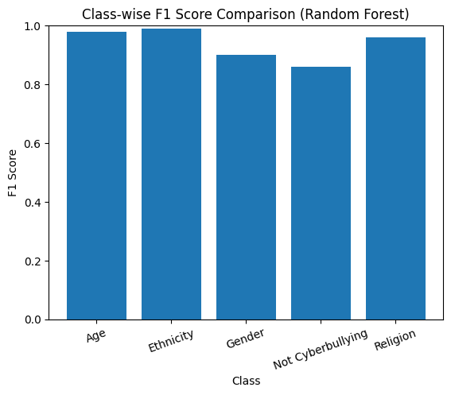
Figure 33 F1 score comparison
This illustrates the class-wise F1 score distribution for the Random Forest model. The age, ethnicity, and religion classes achieve high F1 scores, indicating strong classification performance, while the gender and not cyberbullying classes show comparatively lower scores, reflecting higher overlap with other categories.

Discussion
The test dataset evaluation confirms that the Random Forest model provides strong and reliable performance for cyberbullying classification. High accuracy, balanced F1 scores, and consistent class-wise behaviour demonstrate that traditional machine learning models remain effective when combined with appropriate text preprocessing and feature representation.
The results also highlight specific areas for improvement, particularly in distinguishing gender-related cyberbullying from neutral content. Overall, the Random Forest model serves as a strong baseline for comparison with more complex approaches such as transformer-based models.
The observed misclassification patterns and variation in toxicity prediction performance can be partially attributed to dataset characteristics. Overlapping language usage between abusive and non-abusive contexts affects class separability, particularly for gender-related cyberbullying. Similarly, the limited representation of extreme threat-related content reduces the ability of regression models to accurately learn these patterns. These findings highlight the influence of dataset composition on model behaviour and reinforce the importance of cautious interpretation when applying trained models to new or unseen data sources.
DistilBERT Classification Results
DistilBERT was trained and evaluated to analyse the performance of a transformer-based model for cyberbullying classification and to compare it with traditional machine learning approaches. Training was performed on a CPU environment for a fixed number of steps, with validation performance monitored during the training process. (Joe, 2024)
During training, certain classification layers were newly initialised, as DistilBERT was adapted for the cyberbullying classification task. This required task-specific fine-tuning to enable meaningful predictions.
Training Behaviour and Validation Performance
The training process showed a steady decrease in training loss and validation loss, along with a consistent improvement in validation accuracy.
Training Step | Training Loss | Validation Loss | Validation Accuracy
100 | 0.6726 | 0.4432 | 0.8795
200 | 0.3163 | 0.2973 | 0.9101
300 | 0.2605 | 0.2503 | 0.9236
400 | 0.2316 | 0.2439 | 0.9259
500 | 0.2142 | 0.2433 | 0.9280
Table 8 DistilBERT training and validation performance
The results indicate stable convergence, with validation accuracy improving consistently as training progressed. The validation loss stabilised towards the end of training, suggesting that the model had reached a reasonable level of generalisation without severe overfitting.
Overall Test Performance
After training, the DistilBERT model was evaluated on the unseen test dataset containing 7,974 samples.
Metric | Value
Accuracy | 0.9280
Weighted F1 Score | 0.9282
Test Samples | 7,974
Table 9 Overall test performance of DistilBERT
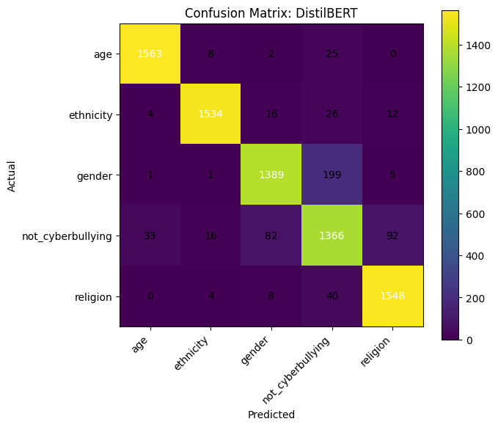
Figure 34 Confusion Matrix
The confusion patterns indicate that misclassifications primarily occur between semantically overlapping categories, reinforcing the observation that cyberbullying detection is constrained by linguistic ambiguity rather than model capacity alone.
The model achieved a test accuracy of 92.8 percent and a weighted F1 score of 92.82 percent, indicating strong classification performance across classes. Although effective, these results are slightly lower than those achieved by the best classical model.
Class-wise Performance Analysis
To better understand class-level behaviour, precision, recall, and F1 scores were analysed for each category.
Class | Precision | Recall | F1 Score | Support
Age | 0.98 | 0.98 | 0.98 | 1,598
Ethnicity | 0.98 | 0.96 | 0.97 | 1,592
Gender | 0.93 | 0.87 | 0.90 | 1,595
Not Cyberbullying | 0.82 | 0.86 | 0.84 | 1,589
Religion | 0.93 | 0.97 | 0.95 | 1,600
Weighted Average | 0.93 | 0.93 | 0.93 | 7,974
Table 10 Class-wise classification results for DistilBERT
The age and ethnicity categories show strong performance, with high precision and recall values. Like the classical model, reduced performance is observed for the gender and not cyberbullying classes. This indicates that semantic overlap between these categories affects both traditional and transformer-based approaches.
Training Time and Computational Cost
An important aspect of the DistilBERT evaluation is training time. Training required approximately 3,335 seconds, which is significantly higher than the training time required for classical models. This increased computational cost highlights a key limitation of transformer-based models when compared to traditional approaches, particularly in resource constrained environments.
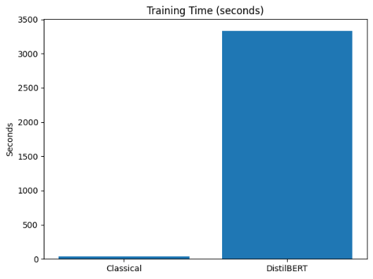
Figure 35 Training Time and Computational Cost
The significant difference in training time between classical models and DistilBERT highlights an important practical consideration. While transformer-based models offer strong representational power, their computational cost may limit scalability and accessibility in real-world moderation systems. This observation supports the inclusion of efficiency as a key evaluation criterion alongside predictive performance.
Discussion
The DistilBERT model demonstrated strong learning behaviour and achieved competitive classification performance. However, it did not outperform the best classical model in terms of accuracy or weighted F1 score. Additionally, the high training time represents a significant trade-off. (Hzami, 2025)
These findings suggest that while transformer-based models offer powerful representation learning, they do not always provide superior performance for all text classification tasks. In cases where well-engineered features and sufficient data preprocessing are available, traditional machine learning models may remain more efficient and practical.
Comparison Between Classical Model and DistilBERT
A direct comparison was conducted between the best-performing classical model (Random Forest) and the transformer-based DistilBERT model to evaluate their effectiveness for cyberbullying classification. The comparison considers predictive performance as well as computational efficiency.
Overall Model Comparison
Model | Accuracy | Weighted F1 Score | Training Time (seconds) | Key Observations
Classical (Random Forest) | 0.9396 | 0.9401 | 37.73 | Higher accuracy, fast training, efficient deployment
DistilBERT | 0.9280 | 0.9282 | 3335.30 | Strong contextual understanding, high computational cost
Table 11 Comprehensive comparison between Classical model and DistilBERT

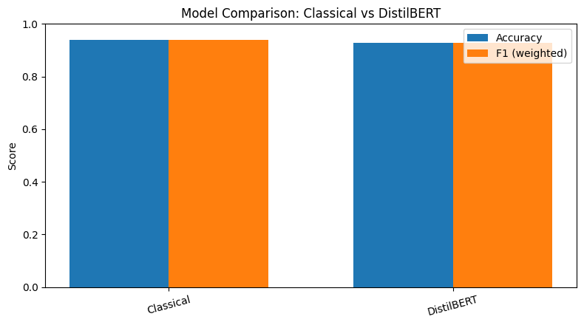
Figure 36 model comparison

The classical Random Forest model achieved the highest accuracy and weighted F1 score, outperforming DistilBERT on the test dataset. In addition, it required significantly less training time, making it more suitable for practical and resource-constrained environments.
Although DistilBERT demonstrated strong learning behaviour and competitive performance, the increased computational cost did not result in improved classification accuracy. Both models exhibited similar misclassification patterns, particularly between the gender and not cyberbullying classes, indicating that semantic overlap in language remains a challenge regardless of model complexity.
The comparison highlights that traditional machine learning approaches can remain highly effective for cyberbullying classification when combined with appropriate preprocessing, while transformer-based models may be better suited for tasks requiring deeper contextual understanding or larger datasets.
Explainability Analysis Using SHAP and LIME
In addition to evaluating predictive performance, this study places emphasis on understanding how different models interpret textual input and arrive at their predictions. To support this objective, explainability techniques based on SHAP and LIME were applied to both the classical TF-IDF–based classifier and the transformer-based DistilBERT model. These techniques provide insight into the contribution of individual words toward the final classification decision.
The explainability analysis was conducted using a representative input text:
“idiot read entire Quran many hadith”.
This example was chosen as it contains both an explicit insult and references to religious terms, making it suitable for analysing how models differentiate religion-related cyberbullying from other categories. (Dalvi, 2020)
SHAP Analysis for the Classical Model
For the classical model trained using TF-IDF features, SHAP explanations were generated at the token level. For the given input text, the model assigns the highest prediction probability to the religion category, with a confidence score of 0.66, while all other categories such as age, ethnicity, and gender receive negligible probabilities.
Despite the correct classification, the SHAP contribution values for individual tokens are close to zero. Words including “Quran”, “hadith”, “idiot”, and “read” show minimal influence in shifting the prediction from the base value. This indicates that the classical model does not strongly attribute its decision to specific words in a transparent manner.
This outcome reflects a known limitation of TF-IDF–based representations, where words are treated independently and contextual meaning is not captured. As a result, the model relies on global statistical patterns rather than interpretable, word-level reasoning.
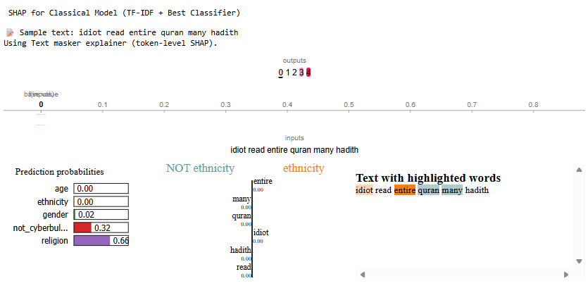
Figure 37 SHAP Analysis for the Classical Model
SHAP Analysis for the DistilBERT Model
SHAP explanations for the DistilBERT model reveal a more context-aware interpretation of the same input text. Unlike the classical model, the SHAP force plot shows a clear deviation from the base value, driven by multiple tokens contributing cumulatively to the final prediction.
Sub word components derived from “Quran” and “hadith”, along with surrounding words such as “read” and “entire”, actively influence the prediction score. This demonstrates how DistilBERT processes text at a sub word level and captures semantic relationships between words. The contributions observed in the SHAP visualization indicate that the model’s decision is shaped by contextual understanding rather than isolated keyword presence.
LIME Analysis for the DistilBERT Model
LIME was applied to further interpret the DistilBERT prediction at an instance level. The LIME output shows a very high prediction confidence of 0.94 for the religion category, confirming the model’s strong certainty.
LIME highlights key tokens such as “Quran” and “idiot” as the most influential features contributing to the classification. The highlighted text representation clearly identifies which parts of the input text were decisive, making the model’s reasoning accessible and easy to interpret.
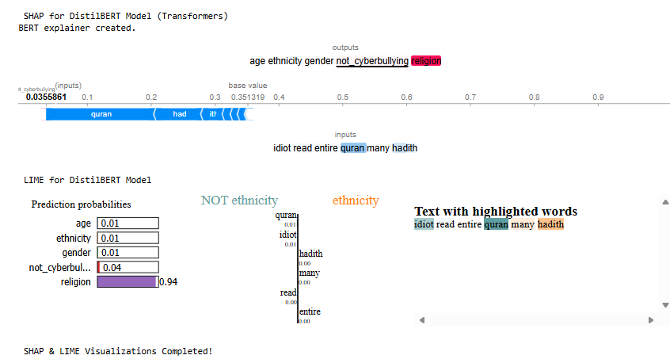
Figure 38 LIME Analysis for the DistilBERT Model
Discussion and Interpretation
The explainability results highlight a clear difference between the classical and transformer-based approaches. While the classical TF-IDF model produces accurate predictions, its explanations lack strong word-level attribution, limiting interpretability. In contrast, the DistilBERT model demonstrates coherent and meaningful explanations, supported by both SHAP and LIME, due to its ability to capture contextual and semantic information.
The consistency between SHAP and LIME explanations strengthens confidence in the DistilBERT model’s decision-making process. These findings underline the importance of explainability techniques in validating model behaviour, particularly for applications such as cyberbullying detection, where transparency, trust, and accountability are critical.
Toxicity Prediction Results
This section presents a detailed evaluation of toxicity-related prediction tasks using both multi-label classification and multi-output regression. The aim of these experiments is to assess how effectively different machine learning models can predict categorical and continuous toxicity-related attributes from textual data.
1. Multi-Output Regression Results
In addition to classification, multi-output regression was used to predict six continuous toxicity-related attributes: Insult, Threat, Identity Attack, Profanity, Toxicity, and Severe Toxicity.
Performance was evaluated using Mean Squared Error (MSE) and R² score for each target.

Mean Squared Error Analysis
Model | Insult | Threat | Identity Attack | Profanity | Toxicity | Severe Toxicity
Random Forest | 0.0327 | 0.0129 | 0.0273 | 0.0300 | 0.0372 | 0.0168
Linear Regression | 0.0427 | 0.0153 | 0.0239 | 0.0408 | 0.0467 | 0.0207
KNN | 0.1279 | 0.0161 | 0.0548 | 0.1343 | 0.1530 | 0.0665
Gradient Boosting | 0.0300 | 0.0151 | 0.0219 | 0.0260 | 0.0329 | 0.0140
MLP | 0.0519 | 0.0162 | 0.0295 | 0.0557 | 0.0584 | 0.0306
XGBoost | 0.0357 | 0.0236 | 0.0200 | 0.0288 | 0.0375 | 0.0139
Table 12 Mean Squared Error (MSE) for toxicity attributes
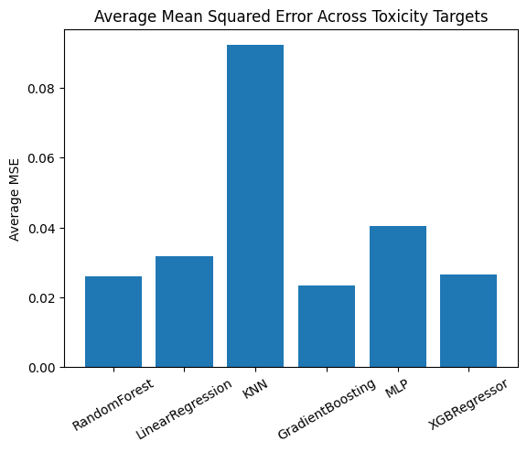
Figure 39 Mean Squared Error Analysis across toxicity targets
R² Score Analysis
Model | Insult | Threat | Identity Attack | Profanity | Toxicity | Severe Toxicity
Random Forest | 0.6042 | 0.1006 | 0.3374 | 0.6737 | 0.5888 | 0.6905
Linear Regression | 0.4836 | -0.0667 | 0.4187 | 0.5564 | 0.4837 | 0.6190
KNN | -0.5455 | -0.1239 | -0.3312 | -0.4612 | -0.6908 | -0.2220
Gradient Boosting | 0.6378 | -0.0506 | 0.4673 | 0.7172 | 0.6360 | 0.7432
MLP | 0.3730 | -0.1331 | 0.2828 | 0.3937 | 0.3542 | 0.4377
XGBoost | 0.5688 | -0.6455 | 0.5151 | 0.6867 | 0.5854 | 0.7442
Table 13 R² score for toxicity attributes
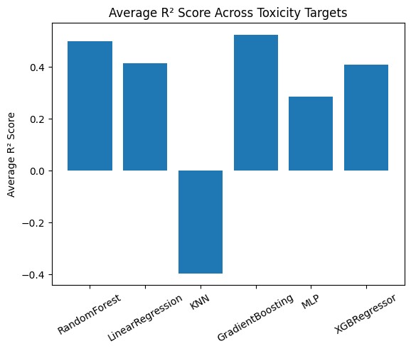
Figure 40 R² Score Analysis across toxicity targets
The variation in R² scores across toxicity attributes indicates that not all forms of harmful behaviour are equally predictable from short text samples. Attributes such as profanity and general toxicity exhibit stronger learnable patterns, while threat-related content remains difficult to model due to sparse representation and contextual dependence. These results highlight the inherent complexity of toxicity estimation and justify the use of ensemble-based regression models.
Interpretation
The regression results show that Gradient Boosting and XGBoost consistently outperform other models across most toxicity attributes. These models achieve lower MSE values and higher R² scores, indicating better ability to capture variance in toxicity severity.
Prediction of the Threat attribute remains challenging for all models, as indicated by low or negative R² values. This suggests that threat-related content may be sparse or difficult to infer from short text samples.
KNN performs poorly across almost all regression targets, often yielding negative R² scores, which indicates performance worse than a baseline mean predictor.
Section Summary
The toxicity prediction experiments highlight the complexity of modelling nuanced harmful behaviour in text. Ensemble-based models such as Gradient Boosting and XGBoost demonstrate superior performance for multi-output regression tasks.

Answers to Research Questions and Validation of Hypotheses
Answer to Research Question 1
How well do traditional machine learning models using text-based features perform in identifying cyberbullying content, and how do their results compare with a transformer-based approach such as DistilBERT?
The experimental results demonstrate that traditional machine learning models perform strongly in identifying cyberbullying content when combined with appropriate text-based features. Among the classical approaches, the Random Forest model achieved the highest test accuracy (0.9396) and weighted F1 score (0.9401).
When compared with the transformer-based DistilBERT model, the classical approach slightly outperformed DistilBERT in both accuracy (0.9280) and weighted F1 score (0.9282). In addition, the classical model required significantly less training time, making it more computationally efficient. These findings indicate that traditional machine learning models can be highly effective for cyberbullying classification and may outperform transformer-based approaches in certain settings, particularly when dataset size and task complexity are moderate.
Answer to Research Question 2
Can regression-based learning methods effectively estimate multiple toxicity related scores from online textual data?
The results show that regression-based learning methods can estimate multiple toxicity-related scores with acceptable accuracy for several attributes, but not uniformly across all dimensions. Ensemble-based models demonstrate clear effectiveness for attributes such as insult, identity attack, profanity, overall toxicity, and severe toxicity, where Mean Squared Error values remain consistently low.
Gradient Boosting achieved MSE values below 0.033 for all major attributes, including identity attack (0.0219), profanity (0.0260), toxicity (0.0329), and severe toxicity (0.0140), indicating stable and reliable predictions. Random Forest and XGBoost produced comparable error levels, with XGBoost achieving the lowest MSE for identity attack (0.0200) and severe toxicity (0.0139). These results confirm that ensemble-based regression models can capture the non-linear patterns required to model toxicity intensity in text.
However, the effectiveness of regression-based methods is limited for certain attributes. Prediction of threat intensity remained weak across all models, despite low absolute MSE values, suggesting insufficient variance and sparse signal in the data. This indicates that threat-related toxicity is not well suited to continuous regression under the current feature representation and may require alternative modelling strategies.
In contrast, KNN and Linear Regression consistently showed higher error values, while the MLP model failed to outperform tree-based ensembles, confirming that more complex or distance-based models do not necessarily improve toxicity score estimation in this setting.
Regression-based learning methods are effective for estimating several toxicity-related scores, particularly when ensemble models are used, but they do not provide reliable estimation across all toxicity dimensions. Their effectiveness is therefore conditional rather than universal.
Answer to Research Question 3
How can explanation techniques such as SHAP and LIME support the interpretation and comparison of predictions produced by different classification approaches?
Explanation techniques such as SHAP and LIME significantly enhance the interpretability of classification results by identifying the words and features that contribute most to model predictions. These methods provide instance-level explanations, allowing users to understand why a particular text sample is classified as cyberbullying or non-cyberbullying.
By applying SHAP and LIME to both classical and transformer-based models, it becomes possible to compare how different approaches rely on linguistic cues. The explanations help reveal overlapping decision patterns, clarify misclassifications, and increase transparency. As a result, explanation techniques support meaningful comparison between models and improve user trust in automated predictions.
Validation of Hypotheses
Hypothesis 1: Classification Performance
- H₀₁ (Null Hypothesis): There is no significant difference in the cyberbullying classification performance of traditional machine learning models and a transformer-based model such as DistilBERT.
- H₁₁ (Alternative Hypothesis): There is a significant difference in the cyberbullying classification performance of traditional machine learning models and a transformer-based model such as DistilBERT.
Conclusion:
Based on the experimental results, the null hypothesis H₀₁ is rejected, and the alternative hypothesis H₁₁ is accepted. The classical Random Forest model achieved higher accuracy and weighted F1 score than DistilBERT, indicating a measurable difference in performance between the two approaches.
Hypothesis 2: Toxicity Prediction
- H₀₂ (Null Hypothesis): Regression-based learning models are not effective in predicting toxicity-related scores from textual data.
- H₁₂ (Alternative Hypothesis): Regression-based learning models are effective in predicting toxicity-related scores from textual data.
Conclusion:
The results indicate that regression-based models are effective for predicting several toxicity-related attributes, particularly when ensemble methods are used. However, performance varies across targets, and some attributes remain difficult to predict accurately. Therefore, the null hypothesis H₀₂ is rejected, and the alternative hypothesis H₁₂ is partially accepted, acknowledging both the strengths and limitations of regression-based toxicity prediction.
Hypothesis 3: Explainability
- H₀₃ (Null Hypothesis): Explanation methods such as SHAP and LIME do not improve the understanding of classification predictions.
- H₁₃ (Alternative Hypothesis): Explanation methods such as SHAP and LIME improve the understanding of classification predictions.
Conclusion:
The application of SHAP and LIME clearly improved the interpretability of model predictions by highlighting influential textual features and explaining classification decisions. As a result, the null hypothesis H₀₃ is rejected, and the alternative hypothesis H₁₃ is accepted.

CHAPTER 6

Conclusion
This project successfully developed and evaluated a machine learning–based system for cyberbullying detection and toxicity intensity prediction in online textual content such as tweets and user comments. By combining Natural Language Processing techniques with supervised learning models, the system was able to identify different types of cyberbullying and estimate the severity of toxic language in a structured and interpretable manner. (Altay, 2018)
Traditional machine learning models using TF-IDF features performed strongly in cyberbullying classification, with Random Forest achieving the highest accuracy and weighted F1 score. Although DistilBERT showed good contextual understanding, it did not outperform the best classical model and required substantially more computational resources. For toxicity intensity prediction, ensemble regression models such as Gradient Boosting and XGBoost delivered the most stable results, though some attributes, particularly threat, remained difficult to predict. The use of SHAP and LIME enhanced model transparency by revealing word-level influences on predictions, supporting explainable and responsible cyberbullying detection.
Finally, the deployment of the trained models through a Streamlit-based web application demonstrated the practical applicability of the proposed system. The application enables real-time analysis for both individual text inputs and bulk data, presenting classification results, toxicity scores, and explanation outputs in a user-friendly manner. Overall, the project validates the effectiveness of machine learning and NLP techniques in supporting automated analysis of harmful online content while maintaining interpretability and usability. (Abdullah Alotaibi, 2025)

Summary of Contributions
This project contributes a practical and empirically validated machine learning framework for cyberbullying detection and toxicity analysis. By integrating classification, regression-based severity estimation, and explainable AI within a deployable system, the work demonstrates both analytical depth and real-world applicability. The comparative evaluation between classical and transformer-based models further provides insight into performance, interpretability, and computational trade-offs, supporting informed model selection for online content moderation tasks.

Future Work
While the proposed system provides a strong and practical foundation for cyberbullying detection and toxicity analysis, several limitations highlight directions for future work.
One important extension involves improving model adaptability. Although transformer-based models demonstrate strong contextual understanding, their computational cost remains a constraint. Future research could explore parameter-efficient fine-tuning strategies, such as lightweight adapters, to enhance performance while maintaining efficiency.
Another limitation relates to the dynamic nature of online language. As abusive expressions evolve over time, static models may struggle to detect emerging patterns. Incorporating continual or incremental learning strategies could enable the system to adapt to new forms of harmful language while retaining previously learned knowledge.
The current implementation focuses on English-language text, which limits its applicability across diverse online environments. Future work should investigate multilingual and cross-domain adaptation to support broader linguistic and cultural contexts, improving generalisation across platforms.
Bias and fairness also remain critical considerations for real-world deployment. Future research could integrate bias detection and mitigation techniques to ensure equitable performance across sensitive categories such as gender, ethnicity, and religion.
Finally, deployment-related risks should be addressed more comprehensively. Future systems may incorporate human-in-the-loop moderation, confidence-aware decision thresholds, and evaluation against adversarial or AI-generated abusive text. Extending the framework to real-time moderation pipelines using streaming data would further enhance its practical relevance. (Alkasassbeh, 2024)

Final Remarks
This project contributes to the growing body of research focused on using machine learning to address cyberbullying and toxic language in online environments. While automated systems cannot replace human judgment, they can serve as valuable decision-support tools by enabling early detection, severity assessment, and transparent analysis of harmful content. (Anwar, 2022)
By combining classification, regression-based toxicity estimation, explainability, and deployment within a single framework, this work demonstrates a balanced and practical approach to online content analysis. With continued research, ethical oversight, and responsible deployment, such systems have the potential to support safer, more inclusive, and more respectful digital spaces.

References
Abdullah Alotaibi, E., 2025. Cyberbullying Detection and Identification Using Machine Learning-Based Hybrid Framework, s.l.: IEEE.
Alkasassbeh, M., 2024. Cyberbullying Detection Using Deep Learning: A Comparative Study, s.l.: IEEE.
Altay, E. V., 2018. {Detection of Cyberbullying in Social Networks Using Machine Learning Methods}, s.l.: IEEE.
Andrea Pereraa, P. F., 2023. Cyberbullying Detection System on Social Media Using Supervised Machine Learning. s.l.:CENTERIS – International Conference on ENTERprise Information Systems / ProjMAN - International Conference on Project MANagement / HCist - International Conference on Health and Social Care Information Systems and Technologies .
Anwar, G. B., 2022. Textual Cyberbullying detection using Ensemble of Machine Learning model, s.l.: IEEE.
Bhat, A., 2022. A Study on Automatic Detection of Cyberbullying using Machine Learning, s.l.: IEEE.
Chowdary, T. R., 2024. Empowering Online Safety: A Machine Learning Approach to Cyberbullying Detection, s.l.: IEEE.
Dalvi, R. R., 2020. Detecting A Twitter Cyberbullying Using Machine Learning, s.l.: IEEE.
Daniel, A. D. a., 2022. Cyberbullying Detection on Social Networks using LSTM Model, s.l.: IEEE.
Elankavi, G., 2024. Identification of social media cyberbullying with the aid of machine learning, s.l.: IEEE.
Haifa Saleh, S. L. L., 2023. Bystanders Unveiled: Introducing a Comprehensive Cyberbullying Corpus with Bystander Information, s.l.: IEEE.
Hzami, M., 2025. Multi-Level Cyberbullying Detection on Social Media Using Machine and Deep Learning Models, s.l.: IEEE.
Joe, K. A. a. B., 2024. Comparison of Machine Learning and Deep Learning Models for Detecting Cyberbullying, s.l.: IEEE.
Kaarthika, H., 2024. Enhancing Cyberbullying Detection Through Keyword Filtering: A Comparative Study of ML and DL Approaches, s.l.: IEEE.
Khan, A. A., 2022. A Study on Automatic Detection of Cyberbullying using Machine Learning, s.l.: IEEE.
Khan, S., 2024. Cyberbullying Detection in Urdu Language Using Machine Learning, s.l.: IEEE.
Lakkshmanan, A., 2024. Emotion-Driven Cyberbullying Detection: A Hybrid Deep Learning Approach Integrating CNN-LSTM and BERT for Enhanced Accuracy, s.l.: IEEE.
Mahmud, M. I., 2022. A Deep Analysis of Textual Features Based Cyberbullying Detection Using Machine Learning, s.l.: IEEE.
Mathew, L. J., 2025. Cyberbullying Dataset Collection for an Enhanced Automatic Detection on Twitter Using Deep Learning Techniques, s.l.: IEEE.
Mathew, L. J. a., 2024. Cyberbullying Detection and Prevention in Social Media Using Machine Learning and Deep Learning Techniques, s.l.: IEEE.
Mathur, S. A., 2023. Analysis of Tweets for Cyberbullying Detection, s.l.: IEEE.
Patel, P., 2025. Cyberbullying Detection Using Deep Learning, s.l.: IEEE.
Priyadharshini, H., 2024. Advanced Cyberbullying Detection: A Hybrid Model Integrated with Naïve Bayes, s.l.: IEEE.
Saha, S., 2023. Bengali Cyberbullying Detection in Social Media Using Machine Learning Algorithm, s.l.: IEEE.
Sathya, 2024. Effective Automatic Cyberbullying Detection Using a Hybrid Approach SVM And NLP, s.l.: IEEE.
Sathya, J. a. H. F., 2024. Effective Automatic Cyberbullying Detection Using a Hybrid Approach SVM And NLP, s.l.: IEEE.
Teng, T. H., 2023. Cyberbullying Detection in Social Networks: A Comparison Between Machine Learning and Transfer Learning Approaches, s.l.: IEEE.
Toktarova, A., 2024. Review of Machine Learning Models in Cyberbullying Detection Problem, s.l.: IEEE.
Vidart, P. a., 2023. Cyberbullying Messages Detection: A Comparative Study of Machine Learning Algorithms, s.l.: IEEE.
Vyawahare, M. V., 2022. Severity Detection of Cyberbullying in Online Social Networks Using Machine Learning, s.l.: IEEE.
Yadav, J., 2020. Cyberbullying Detection using Pre-Trained BERT Model, s.l.: IEEE.
Zotkina, M., 2024. Detection of Cyberbullying in Texts Posted by Users of Social Networks Using Machine Learning, s.l.: IEEE.

